The Investment Survival

Guide

Making the Most
Of
What’s Left of Your Money

By Harvey Sax
Edited By Jesse Wilensky

In 2001, I started investing with the idea that I had to make a living out of it. Now that’s a bold thought, providing for your family, a loving wife and two small boys from the vagaries of the stock market. But I really didn’t have much choice. The company that I had spent the last five years of my life building was a bust, a casualty of the Dot.com bubble. The job prospects for a dot.com executive were bleak. I figured I had nothing to lose by putting to work what I had learned over the years from being a stockbroker, investment banker, entrepreneur, and CEO of a publicly traded company. Fortunately for my family and me, my plan not only worked, but it succeeded beyond my wildest expectations.
I’m not going to tell you everything I know because the truth is that I’m still learning. I am continuing to evolve and refine this craft. Stock market investing may be the only activity that you get better at with age I just turned 60 and over the last 10 years, I’ve made five times my money. Now that might not sound like a lot of money to a small business owner but in the world of stock market investing, it’s huge. That’s good enough to place me in the ranks of the top 10 hedge fund managers in the world had I been one during that time.
This book is not going to teach you about economics. It’s not going to attempt to explain the concepts of investing or try to convince you of the merits of investing for the long term. After all in the long term we are all going to be dead and making the most of what’s left of our money will be somebody else’s problem, not yours.
If you are facing imminent retirement or already retired and are worried that you don’t have enough money to live on, this book will show you concrete and immediate steps to correct that situation. If you are fed up with investing and the false promises of financial advisors and gurus, I will provide you with specific detailed strategies that you can replicate for superior and absolute returns, not that phony baloney relative outperformance. The Investment Survival Guide is not one of those scams that tells you how I turned $20,000 into $5 million. I will not make you rich beyond your wildest dreams but I guarantee I will make the most of the money you have left. And that may be the only guarantee you can get in the investment business. If after reading the Investment Survival Guide, you feel differently, just write or call me and I’ll refund every dime you spent on it.

Yours truly,


Harvey Warren Sax

Table of Contents
The Investment Survival 1
Guide 1
The 24 Hour Rise And Fall Of My Financial Career 4
Investment Choices Today Are Challenging 14
Don't Believe The Hype. You Can Beat The Market 17
So You Think You Got Style. But Which One? 28
Growth Stocks 29
Value Stocks 31
Income Investing: The Zero Interest Challenge 34
Growth and Income 40
Special Situations 45
Macro Investing 48
Market Neutral 52
Short Selling 53
Option Investing 55
Technical Trading 58
Emerging Markets 60
The Black Box: Money Goes In, But Doesn’t Come Out 61
Every Style Can Work, But You Can’t Work Every Style 62
Bulls 63
Owls 63
Lambs 64
Tigers 64
Two Famous Investors – Two Different Styles 67
Have a Plan 69
Mute The TV Volume 70
Technical Analysis Simplified 71
Support And Resistance 74
Oscillate This 77
Divergence- My Favorite Technical Indicator 78
Our Approach: A Working Marriage Between Technical And Fundamental 86
Chart 86
Analysts 89
Insiders 90
Management Discussion 10Q And 10K 93
Market Direction 93
Sector Outlook 93
Cash Flow 94
PEG Ratio 94
Valuation 95
Catalyst 96
So I Think I Like A Stock. Now What? Error! Bookmark not defined.
A Six Figure Income without Buying a Stock? 97
Options Strategy: Cash Secured Put Error! Bookmark not defined.
Rules For The Road 102
Be patient and wait for the opportunity. 103
Trade on your own ideas. 104
Review and learn from your mistakes. 104
You have to be able to sleep at night. 105
Don't risk too much on any one idea. 107
Beware of yesterday's events. 108
Volatility breeds opportunity. 108
Anticipate don’t react. 108
Listen to the markets. 109
Think trades through. 109
If you are unsure just get out. 110
Force yourself to trade against the consensus. 110
Start each day anew. 110
Recognize winners and losers fast. 111
Press your bet when you are right. 111
Force yourself by on extreme weakness, sell on extreme strength. 112
You will never make money in the market if you are too afraid of losing it. 112
Investors Tool Kit 114
Getting Started: We’re Here To Help 115

The 24 Hour Rise And Fall Of My Financial Career

The question strangers ask me the most while riding the chair lift is what do I do for a living? I can see the wheels turning in their head wondering how the hell this guy pulls off living in a ski resort they have spent big bucks visiting and planned a year in advance just to find the time for a vacation. I tell them I am a professional gambler. Gambling has a somewhat unsavory reputation and that usually stops the conversation. I kind of resent people asking me what I do for a living when they haven’t the slightest interest in who I am but just how I got here. It’s nosy, don’t you think?
When I say that I’m a professional gambler, I don’t feel like I’m lying, though. After all if I really wanted to silence my cohabitant on the chairlift, I would say I’m a tax collector. I work for the IRS. But then again a fall from a chairlift could put a premature end to the ski season or worse. In spite of this, some people persist and I elaborate and tell them I trade stocks and bonds; securities for a living. “Oh, you’re a day trader” or “I used to do that” or “Hmm”. It’s then that I feel like pushing them off the chair. The general public seems to think trading is less respectable than investing unless of course you do a whole lot of it. Automated trading programs account for 25-40% of all volume on the exchanges. Quite often in Deer Valley, I’ll share the lift with someone that actually works in the hedge fund industry and then the disdain is palpable. Unless I lie and tell them I manage billions, they think I’m a piker. I don’t bother to explain that the small investor has distinct advantages over the insiders, the PhD math quants, and the financial heavyweights.
My career nearly ended the same year it began. At the time, I was a newly minted stockbroker with Shearson Lehman Hutton. I was ferociously prospecting for new clients while trying to understand this foreign, mad new world of major wirehouses. I had passed all the usual industry hurdles (licensing, etc.) and, in my mind at least, was well on my way to smashing my first year targets.
It was a Monday afternoon when my new manager, Ron Brown called me into his office. He was holding a copy of a newsletter I had written in his left hand and the look of disgust on his face made me feel extremely uneasy.
“What the hell is this?” he asked. Ron was an ex-marine colonel and had a hard-on for me. Maybe he just didn’t like me, or maybe it was because I was a drain on his P&L and was not yet producing any revenue for him, but he had a knack for making me feel it was both.
“It was approved by your compliance officer,” I meekly proffered.
Picking up the phone, he quickly confirmed that piece of information. He then added.
“Well.. Somehow this wound up being sent to Roby Robinson’s wife. And he just called me up asking me what the hell the Sax Angle was.” Roby Robinson was the founder of Robinson Humphrey, an iconic Southeast brokerage house also owned by American Express at the time.
My first reaction was that I had bought a good mailing list.
“Sax, I think you’re going to be a big producer some day... Just not for me. You’re fired,” he said.
He may have been a total ass, but Ron was right about one thing: I did become a big producer. My auspicious start ultimately led to a successful brokerage career which culminated in my departure from the industry to start HomeCom, one of the first publicly traded internet companies. Ironically enough, year later I would have an opportunity to personally meet the man that was indirectly responsible for my firing from Shearson Lehman Hutton when he hired me to help develop his company’s web presence. But this time it was CEO to CEO as I was tasked with building the first web site of Robinson Humphrey. Needless to say, Roby had no remembrance of my fateful termination.
In a span of eight years I was a stockbroker at some of the best firms on Wall Street, and some of the worst. E.F. Hutton hired me shortly after the crash of 1987. E.F. Hutton’s tag line was "When E. F. Hutton talks, people listen" (which usually involved a young professional remarking at a dinner party that his broker was E.F. Hutton, which always caused a lull in the conversation as everyone’s attention now focused on him). It was a great time to go into the business. The crash had opened up the market to new brokers as the senior guys were busy hiding their poor results from their clients.
E.F.Hutton almost didn’t hire me, since one of the psychological pre-employment profile tests came back that I might not be aggressive enough to be a stock broker. Mind you this was a job peddling paper to seniors, not guns and ammo. No one would ever claim E.F. Hutton wasn’t aggressive enough. The check kiting scandal, mob money laundering and massive trading losses and margin calls that its customers couldn't meet forced a merger with Shearson Lehman Brothers/American Express (then named Shearson Lehman/American Express). The merger took effect in 1988, smack in the middle of the first few weeks of my freshly minted employment, and the merged firm was named Shearson Lehman Hutton, Inc.
This proved a fortunate turn of events for me. I had hardly gotten started and now I would be trained on the 101st floor of the World Trade Center in the best sales program in the industry. They had developed a training program for new brokers that incorporated all that they had learned from the most successful salespeople they had. MOST IMPORTANTLY this was a program that could be easily taught and copied. What I learned was that sales ability was a skill, not something you were born with. After this intensive program, I had confidence that I could sell anything, not just stocks and bonds.
For a solid two weeks on end we role practiced asking for the order and handling the objections. It became apparent after a couple of days that were a finite number of objections that could be expressed in an infinite number of ways. We practiced with cue cards, the objections on one side, and the rebuttals on the other. We were instructed that you asked for the order a minimum of five times before you gave up. Not because you were persistent or wanted to be obnoxious, but because you would not discover the real reason why someone wasn’t buying your sales pitch until you had overcome their real objection. People lie. They don’t tell you what they are really thinking. An objection is not something to be won or overcome but something you ferret out the truth with. It’s only after hearing multiple objections, do you find out the real one.
After this training we began our ‘dialing for dollars program’. We started each day at 8:00AM sharp. We were allowed 30 minutes to read the Wall Street Journal and then we hit the phones. They gave each of us (about 120 people from all walks and ways of life) a sheet of paper and a three-minute hourglass. We were instructed not to spend more than three minutes on any one-phone call. They knew that their business was a numbers game. Out of two hundred phone calls per day, they knew you would only reach 50 people, and out of that only ten to twelve of those would be interested in what you had to offer. The outcome of this was one or two of your two hundred calls would ultimately turn into a customer. I remember the crowning event of this training was when one of my fellow unleashed newbie brokers cold-called an elderly lady in Florida. It was one of the first of hundreds of phone calls he would make from the World Trade Center. The woman on the other end of the phone exclaimed, “Oh, I’m so glad you called”, completely unaware 120 Kool-Aid drinking, newly minted stockbrokers were listening in on this conversation, foaming at the mouth over their first taste of meat. “My attorney just told me to contact Shearson Lehman about this large accident settlement I was just awarded.” He made twelve hundred dollars commission on that cold call. All 120 of us were hooked.
Any doubts on my part that Wall Street was about making the customers money was dismissed during my internship atop the World Trade Center. Only one week of training was actually devoted to product knowledge. The rest was about the hourglass and sales. It was all about making the firms you worked for money and the customers were just an incidental part of the process. Of course they all professed suitability concerns and providing the best advice for the customer, but the impression I got was this was more driven by fear of litigation than genuine interest in the well being of the client. The old adage “Where are the customer’s yachts?” never seemed more apropos.

After Ron Brown and my forced early departure from Shearson, I began to look for a new job. It didn’t take long. Drexel offered me a position the same afternoon I was fired from Shearson but the manager suggested I might not want to work there. They were shut down shortly thereafter. Moving on down the street, I found Bear Stearns. They hired me that same day. I didn’t know much about them, but the energy felt good and the office space was first class.
Quick to employ my newly acquired talents, I thought I was well on my way to success when the manager, Mike Margolis called me in to his office. “Sax, don’t sit. What the hell kind of numbers are these?” I was shocked as I stammered something about how I was now making six figures and had only been in the business a year.
“Those numbers might cut it at Shearson Lehman Hutton but this is Bear.”
“What do you need me to do?” I asked, ready to rise to the challenge.
“Twice that for starters,” Mike said.
I went back to my office and doubled my efforts. Soon enough I was doing twice the production. To Bear, it didn't matter what your numbers were, all that mattered is that they kept getting better. It just goes to show how well a kick in the pants works. Bear was an efficient money making machine. The CEO while I was there, Ace Greenberg, was quoted as saying “we are really looking for people with PSD degrees”- that is, those who were poor and smart, with a deep desire to become rich.
I look back at my experience working for the major brokerage houses, all the training programs I paid painfully close attention to, the insanely late hours I spent in those tiny cubes hammering at the phones, and I really learned just two lessons that still stick with me today. Not to say that these are the only two things I learned in the industry, but they were certainly the two closest things to the truth I ever learned from working in finance. The first lesson was how to sell. The second lesson came shortly thereafter, and it was how to sell big. If I had one memory of my time at Bear that characterized my time there was when the only female broker in the calling room opened a new account with a big order for RJR. The company had recently gone public again after the infamous LBO. She had cold called a farmer in North Carolina and sold him $500,000 worth of Reynolds tobacco stock. Since she had to get a big order from a new client approved, she went to her manager.
“Let me get this straight,” the calling room manager said, “A guy you never met and never talked to before is going to buy a half million dollars of stock… from a chick.” He scratched his chin for a moment, seemingly lost in deep thought.
“Tell you what. You go back to him and tell him to step up to the plate. Ask for a million.”
She did. And he did. That was Bear when I worked there.
I had the best investor education one could buy. I got to learn about trading on my customer's dime. I certainly did the best I could for them. I sold them the brokerage firm's and mutual fund industry's best rated stock and fund ideas. I quickly learned though that brokerage firm's analyst recommendations tell you a lot about the company but little about making money. The disclaimer on every mutual fund prospectus “that past performance is no guarantee of future results” is the most truthful utterance ever made about investing.
Later in my career, while working as a senior broker at PaineWebber, David Blech recruited me for an executive position. Now David was the largest venture capital investor in the biotech industry. He personally owned 5% of the entire U.S. biotech industry. He offered me a personal and corporate guarantee of a million dollars to come work for him. At the time he was Citicorp’s largest private client and a legend on Wall Street.
David hardly looked at me during the interview, pecking at the keyboard pulling up one stock quote after another. After he had agreed to all of my employment terms and requests, he gruffly asked me without looking up from the screen, “Is there anything else?”
“Yea,” I answered after a short pause. “Why does someone worth a billion dollars want more?”
Blech took his eyes off the quote monitor long enough to cast me a curious glance. The slight gleam in his eye was the only thing that stood out from his melancholy face as he said,
“I want to be able to tell Sandy Weil, ‘Fuck You’.”
Sandy Weil was the corporate legend and serial acquirer who assembled the behemoth Citicorp from a group of insurance and brokerage companies, one of which was my erstwhile first employer, Shearson Lehman Hutton.
I learned a lot while working at Blech & Co. The least of which was that I would be suing David a year later for the money he owed me.
At Blech & Co. I got a bird’s eye view of how to raise hundreds of millions of dollars along with priceless insight into the inner workings of both the brokerage and biotech industry. David Blech had a cookie cutter formula for building biotech companies. He would source name brand CEO’s from big pharmaceutical companies and leading scientists from the best universities and offer them tons of stock and wild prospects of riches. Throw in a Who’s Who scientific advisory board and pepper them with stock options. And into this mix throw two or three investment banks and big open market purchases by David Blech and you had a charged particle of a stock, ready to ricochet off the charts at the slightest catalyst. The formula had worked again and again until Blech’s empire collided head on with the most vicious bear market in biotech history. That’s where I, and other successful brokers, were recruited to solve his ‘window’ problem. You see David’s customers, the Wall Street firms and boutique investment banks that bought and marketed his deals, told him they could no longer raise money due to the biotech bear market. “The window was closed.”
Here’s the problem: biotech companies burn money. In fact, most of them are not profitable and never will be. It takes hundreds of millions of dollars to create a drug and shepherd it through the FDA’s exhausting battery of tests and read tape before commercial approval is granted. And David had dozens of investments in companies that all needed money. He didn’t want to hear that the window was closed. He had the hubris that he, with the aid of a select group of established Wall Street brokers, could reopen this window himself. I had the naïveté to believe that this godlike task was within his grasp. Although I admit, the million dollars he personally guaranteed me didn’t diminish my conviction.
There were a lot of illuminating moments at D. Blech & Co. that prepared me for my future investing career. One evening after an exhausting day of investor meetings and telephone conference calls, I took the former Dean of Stanford University Medical School out to dinner. As we were eating, my curiosity finally overcame me and I asked why he would leave such a distinguished and seemingly secure position as Dean of Stanford University Medical School. I was surprised to hear his reasons. He said, “I’m tired of watching my former students get rich starting biotech companies. This time it’s my turn.” As we raised thirty or so million dollars for his company in a private placement, I couldn’t help but think this remarkable bit of candor was strikingly different from a lot of the ‘cure disease and make the world a better place’ bullshit David spewed.
When it became apparent that David could not support the aftermarket trading of his newly public companies, the ferociousness of the raids by the market bears was unenduring. The Street smelled blood and the rampant short selling of his stocks began. This was truly unfortunate as it impacted the lives of many of the hundreds of employees of these companies, the investors in them, and inevitably their very prospects as remote as they might have been of curing disease. But Wall Street is a brutal place and once the smell of blood is in the water, the fear and greed spread at a blistering pace. The dozens of companies we brought public plummeted in price as word spread that David was having capital problems with his clearing firm and my old employer, Bear Stearns. Each day as the stocks spiraled downward in a glorious spectacle of carnage, Bear relentlessly demanded more and more collateral from David. This self-perpetuating death spiral reminded me how sharks bite at their own tails in a bloody feeding frenzy as Wall Street and its investors turned on David. Former customers turned predators took delight in that the stricken Blech was bleeding to death.
I watched in horror from the Ruth Chris restaurant in the lobby of our building, too shaken to even sit at my desk in the office as these Blech stocks began to trade hundreds of times their normal volume with no apparent price movement. Finally Bear Stearns ended the horror show and pulled the plug on David for failing to meet net capital requirements. It seems fitting today that Bear Stearns, once Blech & Co.’s clearing firm and one of the rumored leaders of the bear attacks, succumbed to its own demise from relentless short sellers.
At D. Blech & Co. I learned how companies are built and marketed by Wall Street, how executives are compensated and motivated, how deals are diced and sliced, and sold amongst syndicates. I also learned how stocks are routinely manipulated, how rival firms attack their peers, and inside information is passed around like wafers at Mass. Rumors are fed and swallowed without the slightest indigestion. I was there for a year before his firm imploded in the biggest bear market in biotech history, but it only took a few days to learn that you could lose a billion dollars from hubris alone.
So in 1995, I took a page of out my former employer's book and started my own company. Except it wasn't a biotech, it was a dot-com. I brought HomeCom Communications, Inc. public in 1997. Just three short years later, Deloitte & Touche ranked it as one of the Fastest Growing Tech Companies in 2000 (#219 on the Fast 5000 with a five-year growth rate of 1899%. I was the CEO and Chairman of the Board of a publicly traded company replete with expensive lawyers and accountants from a big 6 firm. Attorneys poured over every word I wrote in an SEC filing, accountants scrutinized our revenue recognition, and Wall Street brokerages pumped us for information. Remember, we even built Robinson Humphrey’s first web site. We were huge!
When the dot-com bubble burst in 2000, HomeCom and hundreds of other companies in the Internet business fell on hard times. One thing our bankers and investors had never forcefully emphasized was profits. It was all about revenue growth. Grow the top line and don’t worry about the bottom line was the mantra. While things changed overnight, the warning signs were there before the tech bubble burst. I knew something was wrong when IBM and EDS were offering to hire my employees for twice the over priced salaries I paid them and then telling my customers they would do the same work as we did for the half the cost. And we were not even making money on it!
So at the end of 2000 I negotiated a severance agreement with my company. I was not one of these dot-com executives that cashed out early and walked away rich while the investors went to the poorhouse. I felt I never should sell my stock until the company was on good footing; solidly profitable with the original investors receiving a solid return on their money. Call me naïve.. I was. A lot of people profited on HomeCom, but I wasn’t one of them. But I also stayed out of jail, out of trouble and had no shareholder law suits or disgruntled friends that felt that I had conned them. Peace of mind might not add up in the capital column of a balance sheet, but it does help you live with yourself.
It wasn’t all that long before I told my wife that I was going to try and make a living out of trading the markets. After all this was something I felt I knew a lot about. Although I had plenty first hand experience investing other people’s money, I had never made a living investing my own. Besides, the job market for dot-com executives was the epitome of bleak, even worse than the market today for investment bankers and homebuilder types.
Now I knew I could not afford any costly mistakes in this new venture. Before I started in earnest, I sat about reading everything I could get my hands on that looked worthwhile. It is uncanny how the same principles keep recurring amongst the world’s greatest investors. I crystallized the common themes from all of them into my ‘Stock Market Trading Rules’, which I have devoted a chapter of this book to. Many of them are discussed throughout the book, but I have itemized them in a chapter for your convenience. I have these rules in front of me every day at work. It’s easy to forget and lapse back to old habits.
The first year of full time trading 2001, I earned more than I had in the previous five years combined working as the CEO of HomeCom. I was off to the races. I thought to myself what have I been doing? This is what I should have been doing for years. Overly confident I entered the year 2002 and lost as much money as I had made the last year I had a paycheck. I was still way ahead of the game but much of my confidence had been shaken. If you think trading the markets is an easy way to make a living, think again. It’s not for everyone but then again there is a lot to be said for going to work in your pajamas.
Today I work out of my house overlooking three ski resorts in Park City, Utah. I have spent the last nine years shredding both the finest snow on earth and the S&P 500. I work a few hours in the morning scanning the news, watching the tape for opportunities and then several hours in the evening reading Q’s and K’s, doing research and noting chart patterns. The rest of my time is spent skiing, mountain biking, doing some community service, and mostly hanging out with my family, friends and dogs. I often wonder what I have learned. What edge do I have over the geniuses and financial titans out there? It comes down to a few things. I have set at most every seat at the table. It has given me a 360° view. If you were a doctor, you might call it experience. It’s the difference between fresh out of school with the latest textbook knowledge versus sawing bones for twenty years. There are things that only time teaches you.
So I am here to tell you, you can do it. The reason why I believe most people don’t is because they don’t want you to. Who are they? There ARE people doing a lot better and a lot worse than the market and they don’t want you to know about it. I’ll give you a few examples of ‘they’ and why they are keeping you in the dark. First those that don’t want you to think you can do better.
They are the peer pressure group of fund managers determined to keep their jobs by buying what everyone else is buying. I once sold a million dollars worth of IBM to a fund manager for one of the largest public utilities in the country. He was allowed to manage internally a portion of the utility’s money as long as he bought stocks owned by the outside advisors that managed the majority of the utility’s funds. I picked IBM out to try my theory. I said to him you should buy IBM because of this, this and that fundamental reason. But the coup de grace, the closer was when I said, “Besides, no one ever got fired for buying IBM.” That was all I needed to say. He promptly took down the shares. Unfortunately for him this investment did not turn out so well. He doesn’t want you to know about how he and his ilk are just lambs led to the slaughter.
They are the brokerage firms that own the very stock they sell you. I remember the firms used to announce over the squawk box, that we took down a block of stock today at this price. It was understood that this was an exceptional moneymaking opportunity for the broker. Under the implicit encouragement of the brokerage firm you could reserve stock at a fixed price and then mark it up and sell it to your clients. Of course the analyst liked it! It was inventory and the firm was having a sale on it. We never asked why. It was clearly understood they didn’t want us questioning their opinions. Sale is on today! Come get it while it’s hot and marked up! They don’t want you to know about it!
They are the Wall Street brokerages that were so famously conflicted with the so-called ‘Chinese Wall’ between investment banking and retail and institutional sales. Analysts were under great pressure to issue favorable opinions on companies that Wall Street brokerages were engaged or anxious to sign up as investment banking customers. Although this practice may have ceased or been diminished it is clear that analyst opinions still have an immediate short-term impact on stock prices. They didn’t want you to know about their obvious conflicts of interest. That practice has supposedly ended as a result of Sarbanes Oxley legislation. And even bigger scandal though that no one talks about because it is hard to prove is the trading action their analysts initiate with changes of opinion from buy to sell to neutral all on the same stock in the same year for almost inane reasons. Anyone wonder about that? It’s almost as if they wanted to stir the pot and shake things up to create some trading action. Do you think they would do that?
They are brokers for the Wall Street firms and even the big discount firms like Fidelity and Schwab that push clients toward “wrap accounts”. Since commissions were under siege by the discounters and the advent of Internet based trading, brokerage firms decided a more predicable source of income would be wrap fees. Brokers were encouraged to go out and collect assets rather than sell stocks. The result of this was more and more money concentrated in the hands of fewer and fewer investment advisors who were being funneled enormous amounts of money by Wall Street firms who they in turn showered with commissions and soft dollar fees. Talk about a conflict of interest that still hasn’t begun to be addressed. They are never going to mention this other than in the fine small print of the prospectus.
They are hedge funds and other fund managers who are judged and compensated on short-term performance. The standard hedge fund at the time of this writing is paid 2% of assets under management and 20% of profits. This often encourages investments that deploy excessive leverage and risk to the detriment of their clients. If money managers were on the hook for the losses, I think their historical returns would be quite different. They will never do this.
They are the financial advisors that explain their mediocre performance by comparing themselves to other mediocre advisors. If they set the bar low enough, they can clear it and skate by another year collecting fees. They don’t want you to believe you can do better.
They are lastly you. Investing money takes work. It’s not about hunches and tips or chart patterns or past performance. One thing that stood out from those years, as a broker was how smart people spent so little time managing or thinking about their investments. People that earned $200,000 in a year would spend less than fifteen minutes thinking about how to invest it. They in this case are you. It’s human nature not to want to review your mistakes. You want to forget them. The problem with that is you tend to repeat them.

Investment Choices Today Are Challenging

Without a doubt, investment choices in today’s economy are not as simple as they used to be. Just in the last year we have experienced record volatility, including four consecutive days with 400+ point swings in the Dow. Just in the last month of August, the S&P average daily change was 2.2%. According to Bloomberg’s records, we haven’t seen volatility of this magnitude since 1934.

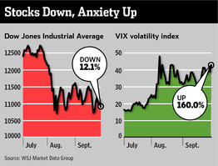

Between the record volatility and the last ten years in the markets being coined as “the lost decade” in terms of returns, there aren’t a whole lot of low risk investment options. Long considered one of the most reliable investment vehicles, real estate has proven more than a challenge. Just take a look at how rapid the drop in home values were in 2008 compared to the Great Depression. As any property owner can attest to, the sharpness of the decline in home values was downright scary and left a path of financial destruction in its wake.

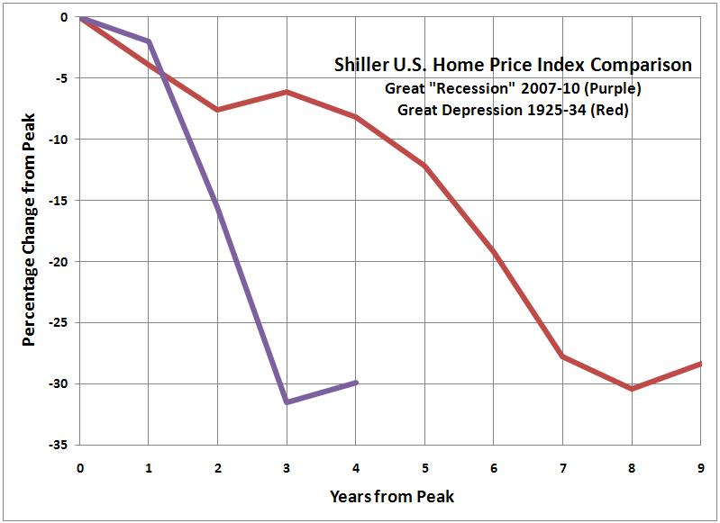

Low interest rates, while they benefit a struggling real estate market, present a whole host of other investment hurtles. The term financial repression should ring a bell, as it’s used by great minds (such as PIMCO’s Bill Gross) to describe the results of an artificially repressed interest rate. Essentially this is when the government keeps rates of risk free investments so low that the return is next to nothing or even negative when you factor in inflation. While this forces investors to look to risk assets for any type of return, not everyone is financially able to participate in the stock market. Individuals on fixed incomes are particularly affected by financial repression since they have no alternative means to participate in the gains of equity markets.

Traditionally a safe-haven for savings, municipal bonds also have some serious headwind due to a low interest environment. Just a small increase in interest rates can leave the bondholder with a fraction of his original principal if they want to sell before the bond matures. Not to mention, as the famed analyst Meredith Whitney is so fond of addressing, the risk of sweeping defaults as state and local governments spend more than they can collect. While her predictions of widespread municipal defaults haven’t materialized in full, unfunded pensions and health care obligations present a serious obstacle. At least 31 states fell below their 80% funding threshold, and 19 states failed to set aside any funding for retiree health care benefits. If these liabilities continue to go unaddressed, the municipal market could become an investment minefield.

So where do you look from here? While sitting in cash is a seemingly safe option, just take a look at the BLS inflations calculator. Cash doesn’t seem quite so safe anymore, and considering all the money printing that fueled the two rounds of the Fed’s Quantative Easing program it’s unlikely that the inflation issue will go away any time soon.

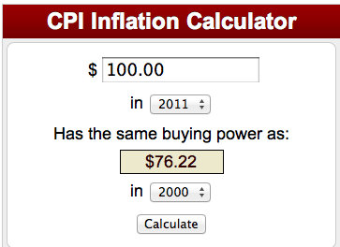


Speaking of government intervention, the political gridlock in Washington doesn’t inspire a whole lot of confidence in the other shaky leg that our economy stands on. So, now that we’ve identified something wrong with almost every avenue of the economy, it’s not all bad. You can make money in the market, just level the playing field.

Don't Believe The Hype. You Can Beat The Market

By now you have probably figured out something is wrong with the picture when you get your brokerage statements. You stash them away with your bills, postponing the opening of this unpleasantness until a future date. Now, if you are close to retirement, you probably have a vivid memory of the robust double -digit market gains of the 80’s and 90’s. What used to be a joyous time examining the appreciating equity of your portfolio is now just a distant memory, like the fun you used to have dating before you got married. You know it must have happened otherwise someone as reasonable as yourself would never have gotten into the predicament you are in now.
If you are relatively new to investing one glance at this chart below will give you an idea of the party you missed.

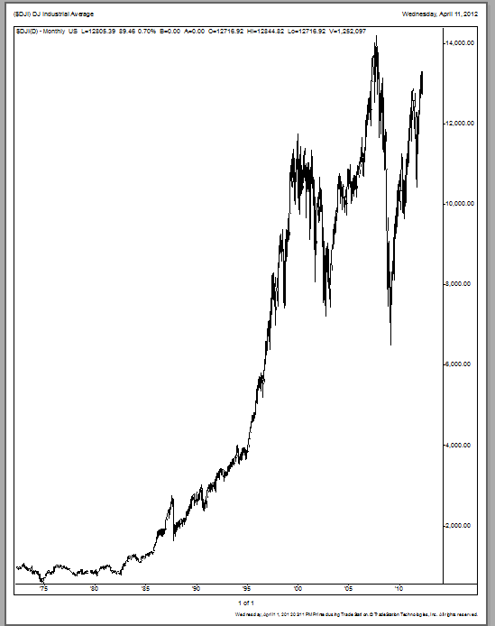
The Extraordinary DJIA Industrial Average from 1980-2000

But like most parties in the real world, this one came to an end too. After all when you look at this chart, why would anyone be surprised? It was just a matter of time when these extraordinary returns would revert to some kind of mean. The Dow had grown over ten times in value over the last twenty years. The answer to the question of when would the party stop came in the attendant hangover known as the tech wreck. If you didn’t get caught up in the frenzied greed and bubble market of the internet and tech stocks, you most likely survived the bubble bursting market meltdown that saw the Nasdaq Composite Index decline from an intraday peak of 5132.52 on March 10, 2000 to a sickening gut wrenching low of 1108.40 on October 10, 2002.

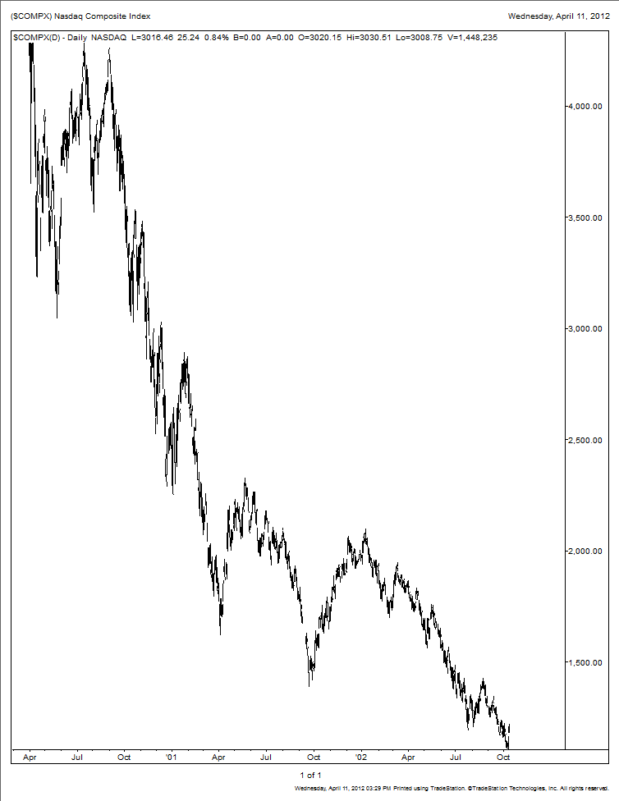
A 78.4% loss on the Nasdaq Composite Index from March 2000 peak to October 2002 trough

A lot of the damage from the dot-com meltdown and year 2000 bubble was confined to the tech sector. I was fortunate in one respect. I didn’t participate heavily in the stock market back then, as I was too busy building my own dot-com bubble company. I founded and ran one of the first internet companies bringing it public in January of 1997. So by the time the dot-com implosion and market meltdown came I was firing people by the dozens and experiencing first hand the market collapse. I did try to make some money by betting against this insanity. I shorted two of the highest fliers in this group thinking that this ride was surely coming to an end. I remember like yesterday I was in Puerto Rico for a rare R&R weekend, trying to decompress and watching the ticker tape below my CNBC TV screen. The tape was scrolling buy repeating the biggest winners and losers of the day. There in bold print were the two stocks I had shorted. They were each up over $100 that day! I said to my wife, it must be a mistake. Puerto Rico is after all a third world type country right? No mistake. One of those high-flyers was a company called Ariba and Commerce One. Both were spectacular flameouts. I covered the position with a $100,000 loss, mostly all occurring on that miserable day in Puerto Rico. Ariba went on to double after my unfortunate bit of market timing. The pain of the loss I took was somewhat mitigated by the fact that I would have lost five times that amount just a few months later if I had stuck to my convictions. Eventually Ariba and the other company I shorted came down to earth providing me with some kind of short-lived moral victory proving first hand Bernard Baruch’s famous quote, "The market can stay irrational longer than you can stay solvent.“
Most investors, particularly, the ‘buy and hold’ type investors survived the Nasdaq crash. It was really the day traders that took the brunt of the punishment. After all if you had been buying the market and holding for the last ten to twenty years you could have afforded a few misadventures in the Nasdaq. I know this from historical and personal experience. Even after the 74% crash, the Nasdaq was still up a whopping 638%. And some stocks were up a lot more.
In March of 1990 I was a stockbroker at Bear Stearns and opened an account with the retired President of Exxon. On a first trade I sold him 10,000 shares of Oracle, worth about $200,000 then. Unfortunately the next day the company announced their accountants were bringing up some revenue recognition issues. It appears that the sales managers at Oracle (they had and still have a reputation for aggressiveness) were counting sales a little prematurely. The stock opened the next day down 50%. Sucking it up, I called my new client and sheepishly explained that the fundamentals were intact and that he should buy more. It didn’t take much convincing and my unlucky client doubled down on Oracle. Many years latter I called my client and suggested he take some profits. He said, “Harvey, I haven’t sold a stock in twenty years.”

“The big money was made in the waiting”. Jesse Livermore

One day while sitting around in 2001(post dot-com tech crash) examining the ruins of the Nasdaq meltdown, I calculated based on my erstwhile client’s “conviction of buy and hold”, what his investment in Oracle must be worth now. I figured that he probably owned the entire amount of stock, the 20,000 shares I sold him. I was curious how much his buy and hold philosophy cost him. The original $300,000 he invested in Oracle was worth nearly $16 million at 2001 depressed prices. That would have been multiples more than his Exxon stock was worth and he was their President! So even in a meltdown like we had with tech stocks, ‘buy and hold’ was far from dead. It was actually working quite nicely.
When I was a stockbroker one of my favorite things to say to clients was that ‘I can’t make you rich, you already are rich. I’m just protecting your investments and getting you a good return on them.” What I didn’t tell them was that I knew this maxim all too well. I had spent years swinging for the fences and striking out while I helped my clients hit base hit after base hit. I could help them run up the score but couldn’t help myself get past first base. I learned this cold hard truth of investing the hard way. It’s not the home runs that make a successful investor; rather it’s getting on base consistently and avoiding the strikeouts that produce winners in the investment game. It was only after I had accumulated some money myself did I start to practice the advice I had dished out. Lose thirty percent of your money in one year; it takes a 60% gain the next year just to get back to even. Not an easy feat to do or a likely one to accomplish for the greatest of investors.
Unfortunately that is precisely what happened to most people in 2008. The S&P 500 (the most widely used measure of investment performance) was down 38.5% in 2008. If you somehow emerged unscathed from the great tech wreck dot-com meltdown of 2000, the 9-11 terrorist attacks, and the brutal 2002 sell-off, you probably didn’t escape this mother of all meltdowns. Most investors, assuming they got market like returns, will have to earn 77% on their investments in 2009 just to get back to where they were at the start of the previous year. Last year was clearly an anomaly, the worst performing year in the market since the Great Depression but the long term investor hasn’t fared so well either. The average annualized return since the beginning of 2001 through 12/31/2008 has been a negative 3.00% for the S&P. Another was of saying this if you put a $1000 into an index fund or a basket of stocks representative of the S&P 500 beginning in 2001 you would have only $780 left at the end of 2008. In fact the ‘buy and hold’ investor would have to have started investing in early 1997 to break even today. That’s right. Eleven years of investing just to break even.
Why would you want to do that? I am certain that if anyone had believed they had a choice between earning nothing; actually losing on their money in the stock market for eleven years or investing in an alternative manner they would have chosen any number of different options. Yet year-end and year out, millions of people do just that. They faithfully dollar average or check off their 401k deductions to put money away every year in a fund that does no better than an S&P 500 like return. The truth of the matter is that most people are brainwashed by the media that they can’t beat the market. They don’t even try.
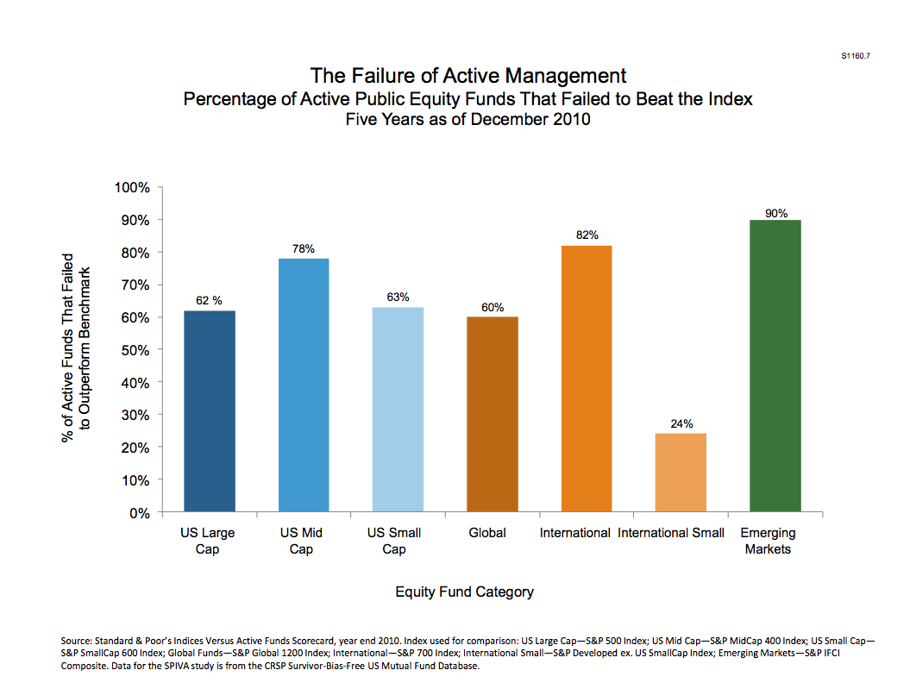

You can beat the market, but most people don’t. It’s always been amazing to me that professional managers, with all the staff, analysts, and resources in the world fail to outperform their benchmark indices. The majority of these professional managers don't even beat a passive index fund. As illustrated in this chart, 62% of large-cap fund managers over the last 5 years failed to meet their benchmark index. 90% of managers of emerging markets fail to meet the benchmark index. Well that's not as much of a surprise, because it's hard enough figuring out what was going on in this country much less another country. There are a few different theories why professional managers fail to beat their indices. For one trading cost, commissions, slippage (the difference between bid and ask) eat at returns. Another theory is if you look inside many actively managed funds they are basically microcosms of the indices themselves. They own several hundred stocks. No wonder you are not going to beat the market investing with these managers. They are pretty much the market. Another reason I think managers failed to achieve superior relative performance is the phenomenon known as herd behavior. They tend to all own the same stocks. After all, “you don’t get fired for buying IBM. “
There are a lot of reasons why this preordained acceptance of mediocrity is a popular belief. Some of it has to do with the real difficulty in managing investments, the time commitment it requires, and the fact that most money managers don’t do any better themselves than the market averages. But I know from personal experience that you can beat the market and beat it by a whopping margin.
In the same time period between 2001 and 2008, a thousand dollars I invested in the market is worth $3187 versus the $780 I would have had if I had if I had accepted the conventional wisdom. That $3187 represents an average annual return of 19.29% without the benefit of compounding. I have to live on my investments and don’t have the luxury of letting them sit there and compound. The returns would have been significantly higher yet. More impressively, that’s after losing 34.3% in 2008. So if you are an investor who is trying to figure out how to make the most of what you have left, this is very encouraging. You can do it.
So I am here to tell you, you can do it. The reason why I believe most people don’t is because they don’t want you to. Who are they? There ARE people doing a lot better and a lot worse than the market and they don’t want you to know about it. I’ll give you a few examples of ‘they’ and why they are keeping you in the dark. First those that don’t want you to think you can do better.
They are the peer pressure group of fund managers determined to keep their jobs by buying what everyone else is buying. I once sold a million dollars worth of IBM to a fund manager for one of the largest public utilities in the country. He was allowed to manage internally a portion of the utility’s money as long as he bought stocks owned by the outside advisors that managed the majority of the utility’s funds. I picked IBM out to try my theory. I said to him you should buy IBM because of this, this and that fundamental reason. But the coup de grace, the closer was when I said, “Besides, no one ever got fired for buying IBM.” That was all I needed to say. He promptly took down the shares. Unfortunately for him this investment did not turn out so well. He doesn’t want you to know about how he and his ilk are just lambs led to the slaughter.
They are the brokerage firms that own the very stock they sell you. I remember the firms used to announce over the squawk box, that we took down a block of stock today at this price. It was understood that this was an exceptional moneymaking opportunity for the broker. Under the implicit encouragement of the brokerage firm you could reserve stock at a fixed price and then mark it up and sell it to your clients. Of course the analyst liked it! It was inventory and the firm was having a sale on it. We never asked why. It was clearly understood they didn’t want us questioning their opinions. Sale is on today! Come get it while it’s hot and marked up! They don’t want you to know about it!
They are the Wall Street brokerages that were so famously conflicted with the so-called ‘Chinese Wall’ between investment banking and retail and institutional sales. Analysts were under great pressure to issue favorable opinions on companies that Wall Street brokerages were engaged or anxious to sign up as investment banking customers. Although this practice may have ceased or been diminished it is clear that analyst opinions still have an immediate short-term impact on stock prices. They didn’t want you to know about their obvious conflicts of interest. That practice has supposedly ended as a result of Sarbanes Oxley legislation. And even bigger scandal though that no one talks about because it is hard to prove is the trading action their analysts initiate with changes of opinion from buy to sell to neutral all on the same stock in the same year for almost inane reasons. Anyone wonder about that? It’s almost as if they wanted to stir the pot and shake things up to create some trading action. Do you think they would do that?
They are brokers for the Wall Street firms and even the big discount firms like Fidelity and Schwab that push clients toward “wrap accounts”. Since commissions were under siege by the discounters and the advent of Internet based trading, brokerage firms decided a more predicable source of income would be wrap fees. Brokers were encouraged to go out and collect assets rather than sell stocks. The result of this was more and more money concentrated in the hands of fewer and fewer investment advisors who were being funneled enormous amounts of money by Wall Street firms who they in turn showered with commissions and soft dollar fees. Talk about a conflict of interest that still hasn’t begun to be addressed. They are never going to mention this other than in the fine small print of the prospectus.
They are hedge funds and other fund managers who are judged and compensated on short-term performance. The standard hedge fund at the time of this writing is paid 2% of assets under management and 20% of profits. This often encourages investments that deploy excessive leverage and risk to the detriment of their clients. If money managers were on the hook for the losses, I think their historical returns would be quite different. They will never do this.
They are the financial advisors that explain their mediocre performance by comparing themselves to other mediocre advisors. If they set the bar low enough, they can clear it and skate by another year collecting fees. They don’t want you to believe you can do better.
They are lastly you. Investing money takes work. It’s not about hunches and tips or chart patterns or past performance. One thing that stood out from those years, as a broker was how smart people spent so little time managing or thinking about their investments. People that earned $200,000 in a year would spend less than fifteen minutes thinking about how to invest it. They in this case are you. It’s human nature not to want to review your mistakes. You want to forget them. The problem with that is you tend to repeat them.
There are tons of ads claiming to have turned $25,000 into $5 million or similar preposterous sums. There are numerous contests each year where people demonstrate returns of hundreds or even thousands of percent per year. I don’t doubt the veracity of some of them. I have even participated in a contest where I produced similar results with make believe money. There are four problems though with these claims:

- Problem 1: The numbers are bogus: They just are patently false, bold outsized lies. One needs to look no further than the preposterous Ponzi scheme Berni Madoff perpetuated for years. All the audits and due diligence you do should not overcome the common sense observation: Does it pass the smell test? Madoff’s consistent results through all market periods did not mesh with his stated investment strategy. In fact numerous students of the market said his ‘split strike conversion’ strategy could never have produced similar results during these time periods. When asked how it outperformed, Madoff shied away from offering detailed explanations with the false ruse that he didn’t want to reveal his secrets. Yes, he didn’t. His real secret was it didn’t work. It was a lie. I’m afraid that’s how the majority of the advertised phenomenal investment techniques are today. When you investigate them further you find they really make no sense. But people fall continuously for new scams. Like the alchemists of yore, people want to believe that you can make gold from lead. If you believe you can make $5 million dollars in three years starting with just $25,000, well don’t read any further. I can’t help you. You are an idiot.
- Problem2: The numbers are often misrepresented. Often times performance numbers do not include management fees. Be sure to check is this before or after fee deductions. Also beware the common hypothetical portfolio or representative portfolio. Often times funds will latch onto a track record that belongs to a former portfolio manager or a different portfolio altogether and extrapolate it as their own. Beware of hard to value illiquid securities. Even the most prominent of managers publish representations that can be highly misleading. For example the most successful of all the endowment funds, the Yale University Endowment fund reported their returns at the end of their fiscal 2008 (June 30, 2008) as up 4.8%. They also showed 49.5% of their funds allocated to private equity and real assets, both illiquid and hard to value assets.
- Problem 3: People can get a hot hand, the element of luck. The time periods investment returns are measured in are too short to be meaningful. When I was a broker, wholesalers of mutual funds would regularly visit our offices. Plying PowerPoint charts and offering catered lunches; they would regale the brokers about their best performing mutual funds. One day I defiantly interrupted a mutual fund vendor and said, “Tell me about your worst performing fund because I have buried too many clients in the best performing ones.” Some managers just get lucky. That’s life and the smartest mathematicians and economists will always postulate that theory. There is also the problem with reversion to the mean. I learned the hard way that the best performing sectors or styles will often meaningfully underperform especially after a banner year. I am sure that if you want to invest in mutual funds you will substantially outperform the averages by picking the worst funds for the previous year or two, not the best ones. Of course Morningstar or Lipper won’t advertise that. Why should they? But if you don’t believe me, just go to the Wall Street Journal and look up the best and worst performing sectors of the market over the last few years and compare them the following years. You don’t have to look past the Year 2000 and the Dot-com meltdown and underperformance of tech stocks or even the less than spectacular performance of the equity in your family home during 2008. All these investments had major markdowns after enjoying stellar runs. Buy the best performing fund manager and you run the risk of catching his year that he reverts to the mean.
- Problem 4: Don’t confuse acting and real life. It’s not real money. This one’s easy yet it amazes me how many sophisticated people fall for it. Returns with make believe money or even real money that is not your own have no bearing whatsoever. It’s as simple as watching kids play army games with fake guns and make believe ammunition. If that analogy doesn’t work for you, try this one. Imagine putting a gun to your head and playing Russian roulette. Try it with and without real bullets. Does the game without real bullets have any similarity to the real one? Of course not. Fabulous returns without the emotional and psychological stress of losing money mean nothing at all. That was the case with the outsized returns on my IRA. Between 2001 and 2004 I turned a $5000 IRA account into over $70,000 in three years, an eye-popping return of over 300 percent per year. And that was with real money! The caveat: the account was so tiny; I only invested in one idea at a time and put everything into it. I would never risk that kind of undiversified approach when dealing with a large portfolio. One mistake and you are finished. But because the account was diminutive, the mentality that this was play money allowed me to be much more aggressive.

So if it's not luck. What is it? Am I smarter than the hundreds of Ivy League whiz kids that the best banks and brokerages in the world hire each year? I am sure the answer by most empirical measures is I am not. Thankfully though, stock market investing is not an IQ test. In fact, I was at the annual Berkshire Hathaway shareholder meeting in May of 2009 and Warren Buffet said if you have a 150 level IQ, you were probably twenty or thirty points too high for a successful investor. Ask any super successful investing legend from Buffett to Soros, and you will get agreement on that if nothing else. They play a good game. Some people are born to play baseball and others have some edge in the investment game. Staying cool under pressure and unemotional while losing money is a far more valuable investing trait than calculus. The unique qualities of successful investors vary with every story. But they all start with knowing which investment style you are going to pursue.

I ski a lot. I have sixty days in so far this year. The question strangers ask me the most while riding the chair lift is what do I do for a living? I can see the wheels turning in their head wondering how the hell this guy pulls off living in a ski resort they have spent big bucks visiting and planned a year in advance just to find the time for a vacation. I tell them I am a professional gambler. Gambling has a somewhat unsavory reputation and that usually stops the conversation. I kind of resent people asking me what I do for a living when they haven’t the slightest interest in who I am but just how I got here. It’s nosey, don’t you think?
When I say that I’m a professional gambler, I don’t feel like I’m lying, though. After all if I really wanted to silence my cohabitant on the chairlift, I would say I’m a tax collector. I work for the IRS. But then again a fall from a chairlift could put a premature end to the ski season or worse. In spite of this, some people persist and I elaborate and tell them I trade stocks and bonds; securities for a living. “Oh, you’re a day trader” or “I used to do that” or “Hmm”. It’s then that I feel like pushing them off the chair. The general public seems to think trading is less respectable than investing unless of course you do a whole lot of it. Automated trading programs account for 25-40% of all volume on the exchanges. Quite often in Deer Valley, I’ll share the lift with someone that actually works in the hedge fund industry and then the disdain is palpable. Unless I lie and tell them I manage billions, they think I’m a piker. I don’t bother to explain that the small investor has distinct advantages over the insiders, the PhD math quants, and the financial heavyweights.
And if you think Warren Buffett, the greatest investor of all time, thinks of investing and gambling as two disparate trades, think again. “The market is a racetrack too,” he is quoted as saying in The Snowball. Peter Lynch in his 1989 bestselling book, One up on Wall Street, devoted the third chapter, Is This Gambling or What, to this subject. It can be summarized in his words, “To me an investment is simply a gamble in which you’ve managed to tilt the odds in your favor.”
So how do you tilt the odds in your favor? After all if you knew the odds it wouldn’t be the investing game. When you walk into a casino in Vegas, you know that every game inside has odds favoring the house. Some games like blackjack offer better odds than let’s say slots, but statistically, you know that every single game has a house advantage.

“If you don't like the odds, don't bet.” Jesse Livermore

The first way you begin to bend the odds in your favor is to have a plan.

So You Think You Got Style. But Which One?

“Bear markets begin in good times. Bull markets begin in bad times.”

I haven’t been able to conclusively cite the origin of the above quote, “Bear markets begin in good times. Bull markets begin in bad times’ but undoubtedly it was from an investor who survived the bear market. The good news is that you can make money in any kind of market. You can profit from the market rising or going down. You can even make money in a market that doesn’t move at all. But what you can’t do is make money without knowing what style of investing you are doing. Ultimately you will only be successful by trading on your own ideas and style but that is going to come with time
Trying to conceptualize an investment style is difficult, due in part to the fact that the concept is about as concrete as a bond trader’s fourth marriage. In today’s world of ETFs, structured products, debt swaps, investment styles seem to increasingly blend together with every hot new product that hits the market. When I started in the industry, this notion wasn’t nearly as convoluted as it is today. However, this next section will provide you with two things: what a style consists of, and some background as to what popular options are available. The reason I think it’s important to familiarize yourself amongst all of these styles is that if you want to be a consistent winner in the stock market you have to be able to play in the every changing panoply of odds and opportunities the market presents. If you are strictly an investor who only can profit from a rising market, you will be better off in an index or managed fund that is devoted to that strategy. If you can only rationalize buying value stocks, you may undergo periods of great underperformance when value is not in vogue like the latter years of the 1990’s when the Internet and technology were the drivers of both the economy and stock market. Try this analogy. You are a clothing storeowner in a typical town in America. Your town has four distinct seasons: summer, fall, winter, and spring. Are you only going to sell clothes for the summer? If that’s the case, business is going to be pretty bad during three fourths of the year.

Growth Stocks

When you think of a stock, most people think of a growth stock. These are the stocks whose price chart starts out on the lower left-hand corner and the price follows some kind and staircase like pattern from lower left to upper right. Growth stocks are fun to own. Everyone likes a winner. Growth companies report increasing revenues and earnings. They are often beating analyst estimates, reporting new successes, new customer wins, and steady progress. This style of investing has the benefit that throwing in with one of these winners early enough can make you rich. Just look at the examples of early shareholders of Microsoft, Wal-Mart cashiers who got stock options, or even those investors that believed in Apple when it started its resurrection in 2002. In just 10 years Apple became the largest company by market cap in the world appreciating over 41 times in value. A $100,000 investment in 2002 is worth $4,125,000 today. Everyone knows a story of someone who owned one of these rocket ships and got rich from it. And for everyone that held on, there are thousands that owned it and sold too early.

The cons of this style of investing: Growth stocks rarely pay dividends, certainly not in their early fast growth stages. You generally are going to pay a higher multiple of earnings for growth. You run the risk of overpaying for growth. Warren Buffett is fond of saying, “you pay a pretty price for a for a cheery consensus.” Another one of the negatives of this style of investing, it tends to be long biased. Volatility in the style of investing can make be expected also to be high.

This type of investment style is not intended for income. When you ask the general public a question about what are the best stocks to invest in, they are invariably going to mention names of growth stocks. It’s easy to understand why. Just look at the real life example of one of my clients who bought Oracle from me. Some of the most exciting returns have been realized with growth stocks. Iconic companies like Apple, Microsoft, Cisco, Oracle, Coca-Cola, Home Depot, McDonald’s, Starbucks, Proctor Gamble, Johnson and Johnson, and host of other names. I think every style of investor would prefer companies that are growing as opposed to stagnant or even shrinking. It’s just a matter of what you pay for this growth. If you can buy them cheap enough, you become a value investor like Warren Buffett.

Bill O’Neil of Investors Business Daily on the other hand would argue that if you are buying a growth stock cheap, there is probably something wrong with it. He is a strong advocate of buying relative strength. “Shares of a company with great fundamentals should be rising compared to all the others. Your best tool to gauge a stocks’ strength is not price. After all, in a bull market even bad stocks can push ahead. Focus instead on the stocks Relative Price Strength Rating”, something IBD publishes. O’Neil popularized a style of investing in stocks with rapidly increasing earnings accompanied with rising stock price. O'Neil seeks out growth stocks with upward price potential. He devised an acronym C-A-N-S-L-I-M to sum up his investment strategy.

C=Current earnings
A=Annual earnings
N=New products and management
S=Supply and demand
L=Leaders
I=Institutional sponsorship
M=Market direction.

There is a lot to be said for the logic here as the great stocks or the ten baggers as Peter Lynch popularized, makes lots of new highs. In this style traders buy or stocks because there are going up and regardless of their fundamentals. Strict adherence to a stock’s relative price is often associated with momentum investing.

Pros: A single investment in a big winner can make you rich. Timing your investment in a growth stock is not critically important if you can buy it early enough in the growth phase as invariably a poorly timed purchase can be salvaged by meteoric growth for a sustained period of time. They are fun to own as they consistently beat earnings estimates and their stock prices are generally on a staircase like uptrend. Everyone likes good news and these companies deliver plenty of it. The challenge often is when you sell? When is the good news all priced in?
Cons: There are never dividends paid by these companies in their early fast growth stages. You generally are going to pay a high multiple of earnings and feel like you are overpaying. They are rarely cheap. Everyone likes a winner but that doesn’t always equate to making money. You’ll be a lot happier owning stocks that make you a winner. You must not confuse a great company with a great stock. When the growth prospects diminish earlier than anticipated these stocks take a brutal hit. The graveyards of the growth investors are crowded with former. As Warren Buffett said, “You pay a pretty price for a cheery consensus.”

Value Stocks

On the other end of the spectrum almost diametrically opposed to growth stocks is category known as value investing. Value investors believe they are buying something below its intrinsic value. This kind of investing can provide a level of safety from the perils of paying too much for a stock. Buying at a significant discount can produce far greater and quicker returns than the best growth stock. Investment value investors don't often fall victim to manias and fads. One of the cons of this kind of investing is something known as the value trap. Value stocks can often be fundamentally troubled companies. Years of under investing in the business can make the company appear more attractive than it really is. One of the problems of this style of investing is what you perceive to be good value is actually a troubled company. Whereas if you're patient but pay too much for a growth company, these companies can often earn their way out of your unfortunate market timing. This is not true in value investing. You tend to buy at a discount in value investing and if the company continues to have problems you find yourself more or less stuck in the stock and you may never get your money out. Bad mistakes in value investing can also be costly as value investors are more likely to continue to purchase stock on the way down as the discount to intrinsic value grows. The capital loss can be greatly compounded by adding to your position rather than cutting your losses. Volatility of these value investments are perceived to be more moderate than growth stocks
In the 1930s, Benjamin Graham and David Dodd, finance professors at Columbia University, laid out what many consider the bible for value investing. The best-known disciple of this approach is Warren Buffett although as I mentioned earlier Buffet really defies categorization. He would undoubtedly argue the only kind of investing is value investing. Buffett called the Intelligent Investor, Graham’s seminal work, “By far the best book on investing ever written.”
In a simplistic sense, the value investor looks to buy a $1 worth of earnings at something considerably less. Graham called this discount to intrinsic worth the margin of safety. Warren Buffett calls them "the three most important words in all of investing." For Buffet, this margin of safety is at least 40%. The value investor seeks companies that seem to be incorrectly valued (undervalued) by the market and therefore have the potential to increase in share price when the market eventually corrects its error in valuation.
This begets the real dilemma and the single most important question an investor will ever encounter. How do you know how much something is worth? Do you value a company by its discounted cash flow, it’s price to earnings ratio, it’s book value, or finally what someone would be willing to pay for it? If the answer were straightforward there would be little price fluctuation in the market. There would also not be much opportunity for the value investor, as people would generally agree on what something was worth. You might argue that is exactly the case. The quoted price of a stock at any time reflects generally what people agree a company’s shares are worth. The value investor doesn’t believe that. Graham created “Mr. Market” as a personification of this collective inherent mispricing as seen in the day-to-day price fluctuation of stocks. It’s not always the case but sometimes ‘Mr. Market’ makes mistakes or gets too emotional and bargains are there for the picking.

Pros: Buying something at a perceived discount can provide a level of safety from the perils of paying too much for a stock. Often times a patient investor can wait out the mispricing and recoup or even profit from his investment. The person who paid too much may never be able to get all of his capital back. There is a common misconception that a good company is a good stock. In reality buying at significant discount can produce far greater and quicker returns than the best growth stock investments. Value investors don’t often fall victim to manias and fads.
Cons: Value stocks can often be fundamentally troubled companies. Years of under investing in the business can make a company appear more attractive than it really is. To stay viable as a business, the company may need to spend more on capital investments thereby diminishing the expected cash flow. It’s difficult to accurately value a stock or company for many reasons not the least of which is accurately projecting the sustainability of future cash flow. Companies with poor business prospects can trade for less than their intrinsic value for a long time as the news flow is poor and investors are unlikely to bid up the price. An investor may have to wait until someone buys out the company to see price appreciation. Mistakes in value investing can also be costly as the value investor is more likely to continue to buy on the way down as the discount to intrinsic value grows. Capital loss can be greatly compounded by adding to your position rather than cutting your losses.

These two charts contrast growth stock investing versus value stock investing. The first is a 26-year chart of Microsoft shortly after it went public. It rose an astounding 40,000%. Ironically HealthSouth, an outpatient surgery and rehab hospital company appreciated the same amount in just 7 months in 2003 after the stock plummeted to seven cents per share when the CEO was charged with cooking the books. The HealthSouth CEO went through 5 different CFOs before he himself wound up in jail but not for cooking the books but rather for political campaign fraud. Apparently his backup plan for buying the Alabama governor backfired. Yet there was still a real business in HealthSouth; the general public just didn’t understand. When shareholders realized this, its stock underwent an amazing rally, rocketing from $.07 to about $28 per share. HealthSouth took just seven months to accomplish what it took Microsoft 12 years to do.

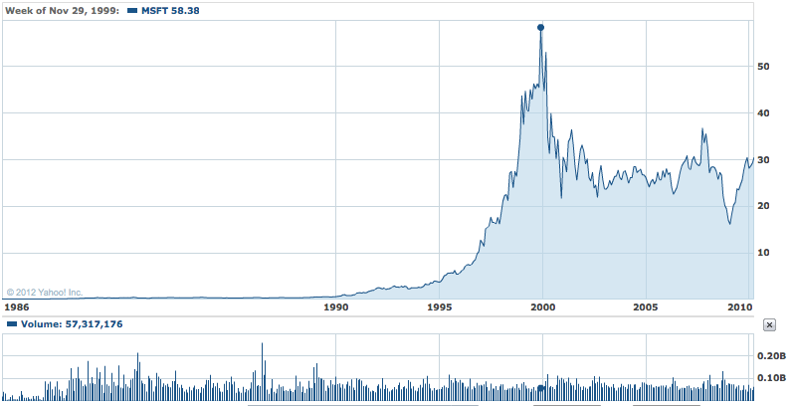

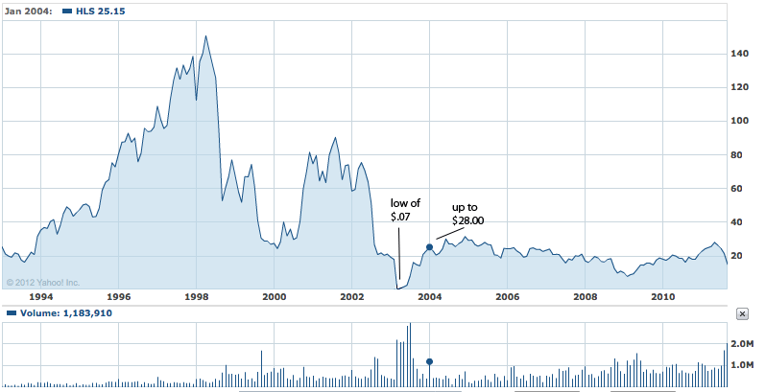

Value or Growth? It took Microsoft fourteen years to go up 40,000%, which HealthSouth accomplished in just seven months.

Income Investing: The Zero Interest Challenge

This style of investing aims to pick companies who provide a steady stream of income from a variety of investment types. When investors think of steady income they commonly think of fixed-income securities such as bonds. However, stocks can also provide a steady income by paying a solid dividend. There are various levels of security provided with debt instruments from senior secured collateral to hybrid securities like preferred stock. As a rule of thumb the yield on an investment is directly related the risk; the higher the yield, the greater the risk. Oddly enough, fixed income securities can be one of the highest risk categories. The guarantee on the returns is often so low that it is impossible to be compensated for the risk no matter how slight it might be. Seldom do I see attractive enough yields to compensate the inherent risks associated with many of the types of investments. The fixed income investor that cites the adage that they are more interested in return of investment rather than return on investment should confine himself to investing in treasury bills and notes, pre-refunded municipal bonds, and Certificates of Deposits guaranteed by the U.S. Treasury. Every other fixed income investment I know of with the exception of high yield (junk) has varying levels and complexities of risk that rarely compensate for the potential loss of capital or investment opportunity.
For example one of the most common mistakes investors in fixed income bonds make is underestimating the interest rate risk. Let’s take treasury bonds where there is no perceived risk of return of capital. A long term Treasury bond, for example a thirty-year bond, is going to fluctuate wildly with interest rates. The longer duration of the debt instrument, the greater the risk associated with rising interest rates. For example if you bought a thirty-year Treasury bond bought at par ($100 equivalent to a $1000 face value bond) at 5% yield to maturity and after ten years, the interest rate on this security rises to 8% your bond is going to be worth about 28% less. That’s a lot to lose on a guaranteed security. The reverse is also true. If rates go down from the time you bought the security, it will rise in value. This fluctuation is fine if you plan to hold the instrument to maturity, your buying power is not ravaged by inflation, and you don’t mind having your portfolio marked down twenty percent. Spend a few moments examining the table below and you will see how just small variations in interest rate can have momentous impact on your fixed income investment.
This style of investing encompasses a variety of products such as Government, corporate, convertible bonds, and municipal debt. Even some investment vehicles such as utilities, MLP’s, and trusts act like fixed income products but are really equity. A fixed income product usually has priority in claims in the liquidation of the issuer in the case of insolvency. Senior debt is higher in the pecking order than junior debt and secured debt is senior to unsecured

Income investing in a near zero interest environment is particularly challenging. In fact it might be downright dangerous to your financial health. Ultra-low interest rates require an enormous amount of capital to live on without dipping into your principal. It’s rarely is a good idea to reach for yield and in this ultra low rate market there is no risk free yield to be found. The Government has lowered rates to near nothing in an attempt to stimulate the economy. This might be good for debtors but it’s been trying for savors. In fact some call it ‘financial repression’. Also fixed income investing is rarely the best way to maximize your money. It tends to be done by more conservative investors who are looking to preserve their money and keep up with inflation. This investor is fond of pithy sayings, like “I’m more interested in return of capital than return on capital”.

One of the benefits of income investing is that it requires a lot less management than stock investing. After all the investor gets a guaranteed fixed rate of interest and a promise that his principal and interest will be paid back, both in a timely manner. How much managing could that that entail? More than you might think. There are two major risks involved in this style of investing.

Event risk: Event risk is what happens if the company that owes you money goes broke. That’s an overstatement to make a point. It doesn’t have to go broke for you to lose money. It’s important to know where you sit in the pecking order; first to get paid or last, senior vs. junior, because a fixed income product is never going to pay you more than the principal amount. If the health of the debt issuer deteriorates, the value of your security will decline as well. Often times just a hint of a debt downgrade can send the price plummeting.

The other risk is interest-rate risk. On a fixed income investment if interest rates go up, the value of your instrument bond or security you own goes down. The reverse is true. If rates go down, the value of the investment will go up. The longer term the instrument is the more it will be impacted by this interest rate effect. A long-term bond will go down for more than a short-term bond. A fancy word for this is convexity. Next time someone calls you up to sell you a bond, ask him or her about the convexity of the security. They’ll be impressed and if you’re lucky never call you again. The reason I say ‘lucky’ is that you can drive a truck through the bid and ask of your bond salesman’s offer. Assume it will take almost a year just to get back the commission and the slippage on a typical muni bond.

One of the benefits this style of investing is very low volatility. Nothing much happens in fixed income investing until it does and then it’s usually bad. Given that likely the worst that can you expect from investment grade bonds is just a shabby return, you can minimize the interest rate risk by laddering and diversifying. Laddering is when you have maturities of bonds coming due at different periods of time, for example, 1,3,5 7,10,15 and 20 years. As each bond comes due and pays you off, you can reinvest the proceeds. If the rates are higher at the time, you benefit from a higher return. if the rates are lower, well the longer-term bonds that you have in a portfolio will go up and you will still have some bonds at now higher rates as opposed to having everything in short-term bonds. If rates go even lower then the value of your existing portfolio will most likely rise dampening the disappointment of being unable to reinvest your money at the higher rates.

Maturity laddering is a win-win for investors. If you are going to be a fixed income investor this strategy makes the most sense. The biggest drawback today is you have to be a billionaire to make any money from it. The Federal Reserve’s policy of keeping rates near zero has penalized most fixed income investors with historically low yields. Once the policy changes look out below. The value of bonds will drop so fast as to make your head spin.

The table below lists bond prices and the corresponding price changes for bonds with a coupon rate of 5% for several different market interest rates and bonds of different terms.

Interest Rate | Term | Bond Price | Price Change | YTM
6.0% | 1 Year | $990.43 | -0.96% | 6.00%
6.0% | 5 Years | $957.35 | -4.27% | 6.00%
6.0% | 10 Years | $925.61 | -7.44% | 6.00%
6.0% | 20 Years | $884.43 | -11.56% | 6.00%
7.0% | 1 Year | $981.00 | -1.90% | 7.00%
7.0% | 5 Years | $916.83 | -8.32% | 7.00%
7.0% | 10 Years | $857.88 | -14.21% | 7.00%
7.0% | 20 Years | $786.45 | -21.36% | 7.00%
8.0% | 1 Year | $971.71 | -2.83% | 8.00%
8.0% | 5 Years | $878.34 | -12.17% | 8.00%
8.0% | 10 Years | $796.15 | -20.39% | 8.00%
8.0% | 20 Years | $703.11 | -29.69% | 8.00%

Investment grade corporate bonds yield significantly more than treasuries but the risk of default is greater. You still have interest rate risk and less of a guarantee of return of your capital. The longer you go out with corporate bonds the risk rise significantly. A triple AAA General Electric three-year note was quoted at a 1.769% yield whereas GE’s 30-year issuance was yielding 8.29%. It is impossible to predict with much certainty events this year much less thirty years out. Companies’ fortunes rise and fall with the economic tide and their own particular circumstances. Junk bonds are typically rated at 'BB'/'Ba' or less. They will pay substantially more than investment grade issues. The yield varies widely based on perceived default risk. Evaluating a junk bond is not all that different than valuing an equity. Michael Milken is credited with popularizing junk bonds based on the academic theory that buying a basket of high yield bonds provides a higher real yield than investment grade when all defaults are factored in.
Municipal bonds are generally considered secure when they are G.O (General Obligation bonds) and often an additional layer of security is provided with a guarantee from an insurance company. As recent events have borne out, the guarantee can lull you into a false sense of comfort as most of the guarantors themselves have had financial solvency issues. But it’s hard to rationalize investing in municipal bonds considering the paltry yield of 5.21%. They have the same interest rate and loss of purchasing power risk as Treasuries.
Preferred stock is a hybrid investment vehicle that pays a higher dividend than the common and is higher up in the pecking order although junior to secured and unsecured debt of the company. Usually these are perpetual preferred so the interest rate risk of rising rates is severe, the collateral is inferior, and the upside is nil. Why you would want to invest in these is beyond me unless you are Warren Buffett and can get a superior yield, warrants, and a sidebar deal that the company won’t screw you over. Since this is never offered to me, I don’t buy them.

In the 3rd quarter of 2011 long-term treasuries went up 23%. In fact the best performing asset class in 2011 was the 30-year U.S. Treasury bond. Anything that can go up 23% in a quarter can also go down just as quick. That’s precisely what will happen if inflation picks up and the market anticipates significant Fed tightening.

If you believe inflation is a consequence of artificially low rates, then consider
Treasury Inflation Protected Securities (TIPS). The 10-year Treasury yields about 2% today but TIPS offer 4.2%. These securities are combination of a promise by the US government to give you a certain rate fixed rate of interest and the rate is adjusted based on the CPI index. If inflation rises as measured by the Labor Department's Consumer Price Index then you will get paid a higher coupon. On the other hand if we are in a deflationary environment and the CPI index is falling, you will get a smaller coupon. On the positive side of that scenario, bonds like deflation. So even if the coupon goes down, bonds in general will probably rise.

There are a number of equity instruments that behave a lot like fixed income investments. Not to be confused with traditional fixed income, these are NOT debts of the issuer but equity with a high dividend yield. They are mentioned here, as they tend to be very sensitive to the direction of interest rates:

A pseudo-like fixed income investment that has been popular and performed well for several years are master limited partnerships, MLPs. These are tax advantaged investment vehicles that are mostly concentrated in the oil and gas industry. These generally have payouts anywhere from 5 to 9%. One of the disadvantages of the MLPs that you should be aware of is that overnight without any warning they may decide they're going to raise more capital and issue a spot secondary below the market. If the company has a history of being well run and using investor money wisely, it will rebound in time because the money raised is used buy or build more pipelines, storage facilities, and other types of investments. Another risk is that the Government is hungry to find ways to decrease the deficit and one of the things they're looking at are tax-advantaged businesses. You certainly have some risk with the government changing the rules of the game. You may not get much warning and the stock market has way of reacting in front of the news. These investments would decline sharply if the Tax policy were to change.

REITs, Real Estate Investment Trusts provide an income stream from office buildings, shopping centers, apartment complexes, and even hotels. A lot of people disenchanted with the stock market have been buying rental properties, paying cash for them and getting a net return of 4-5%. Did you know that you could get these kinds of returns by owning REITs without the headache of tenants calling you all hours of the day with complaints about stopped up toilets or leaking roofs? Combined with the prospects of appreciation, instant liquidity, and similar income streams, these REITS may offer advantages to owning real property.

Mortgage REITS have yields in the vicinity of 14%. They are baskets of mortgages, commercial or residential. They are much more speculative investments and they tend to be heavily leveraged. Whenever anything yields this high, there's a fairly heavy level of disbelief that this income stream could last forever. There has been lot of insider buying in these names so the returns might be better than the market expects.

Junk Bond ETF's are baskets of corporate high-yield debt. It’s safer to buy baskets of these lower rated corporate bonds than individual issuers. The impact of a debt downgrade or a bankruptcy of an individual issuer is minimized by diversification. You can also by emerging market government debt that pays substantially more than some developed countries. These sovereign bonds can be purchased in ETFs. Sophisticated investors can go out and buy sovereign individual bonds but the average investor will be better served to invest in the ETF. Timber, oil, and gas producing wells are bundled and the income stream from them is sold as trusts. Several of these are publicly traded and can provide superior income streams to the fixed income investor. It’s important to remember that the stream of income from these properties has a finite life with limited prospects for creasing on improving on it. A 7 or 8% yield may not be 7 or 8% yield forever and the end result could even be 0%. At least timberland is a renewable resource unlike oil and gas wells.

Pros: An income investment takes a lot less management. The kind of fixed income investments that make sense, short to medium term bonds from strong credits, need little if any investment advice. Fees should be absolute minimum or non-existent. These investments can provide a reliable income stream not subject to the fluctuations of the stock market. TIPS (Treasury Inflation Protected Securities) can theoretically protect your principle and purchasing power.

Cons: Fixed income investing is rarely the best way to maximize your money. In a zero or low interest environment you will need to have a lot of money to live on without dipping into your principal. Event risk and interest risk are the two major obstacles-you rarely get compensated for the risk you subject yourself to.

This style can have very low volatility, and low risk if properly laddered and diversified.

Growth and Income

Most people associate this category with blue chips. Generally, a Growth and Income companies will have healthy balance sheets, consistent dividend payments, quality products and services and experienced management teams. Usually Growth and Income companies are industry leaders, displaying steady earnings growth.
Companies that continually exhibit stable earnings growth, more than anything else, are ones that should hit the radar screens of Growth & Income investors. After all, companies exhibiting all of the characteristics mentioned earlier should have no problem producing a steady stream of profit growth, right?
Large-cap companies generally paying dividends are called blue chips. This style of investing did well in 2011. It actually has done well for many years. According to Standard and Poor’s, the dividend component has been responsible for 44% of the total return of the last 80 years. So think about that. When you invest in a growth company that pays no dividend you're giving up 44% all the upside of investing. The biggest risk with these kinds of investments is investors inadvertently start focusing on the dividend component instead of a balanced approach of growth and income. After all the company paying 2 1/2% by growing their dividend by a few percentage points every year will be a much better investment then that company that has static growth and pays a 5% dividend, twice the rate but never raises its dividend. You have to take pains to balance growth with yield and watch the balance sheet. Heavily indebted companies may not be able to maintain their dividend during a business downturn.

Unlike most compromises, this one actually works. Generally income investors end up focusing on older, more established firms, which have reached a certain size and are no longer able to sustain higher levels of growth. These companies generally no longer are in rapidly expanding industries and so instead of reinvesting retained earnings into themselves (as many high-flying growth companies do), mature firms tend to pay out retained earnings as dividends as a way to provide a return to their shareholders.
Dividends are more prominent in certain industries. Utility companies, for example, have historically paid a relatively decent dividend, and this trend should continue in the future.
Income investing is not simply about investing in companies with the highest dividends (in dollar figures). The more important gauge is the dividend yield, calculated by dividing the annual dividend per share by the share price. This measures the actual return that a dividend gives the owner of the stock. For example, a company with a share price of $100 and a dividend of $6 per share has a 6% dividend yield, or 6% return from dividends. The average dividend yield for companies in the S&P 500 is 2-3%.
Another factor to consider with the dividend yield is a company's past dividend policy. Income investors must determine whether a prospective company can continue with its dividends. If a company has recently increased its dividend, be sure to analyze that decision. A large increase, say from 1.5% to 6%, over a short period such as a year or two, may turn out to be over-optimistic and unsustainable into the future. The longer the company has been paying a good dividend, the more likely it will continue to do so in the future. Companies that have had steady dividends over the past five, 10, 15, or even 50 years are likely to continue the trend.

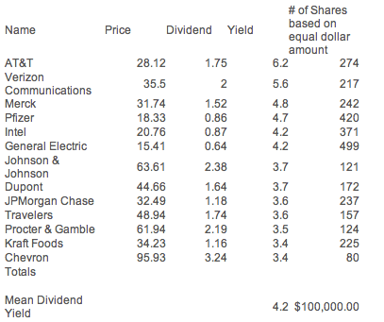
In September 2011 I thought that dividend paying stocks would do well. The table above highlights the 13th highest yielding stocks of the S&P 500.

I took the top dividend yielders from the S&P 500 and divided $100,000 equally between them. The average dividend yield was 4.2%, which is a lot more than you can make in a bank. These are blue-chip stocks. So how well did this hypothetical portfolio perform? We re-examined this portfolio after the 1st week of January 2012 and what we found was the stock market did during the same time. The market had done very well was up about 9% yet this portfolio did far better than the market. It was up about 16% and paid over twice the dividend yield of the S&P 500.
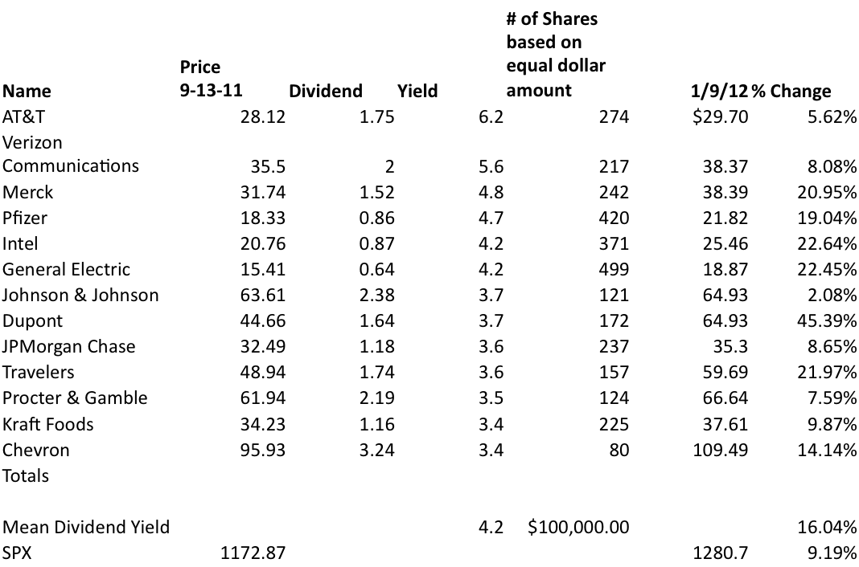

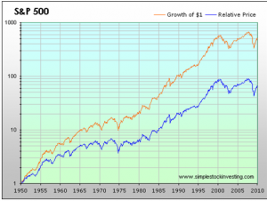
During the last ten years, stocks have had no appreciation as measured by the S&P 500 while many companies still paid and grew their dividends.

Pros: A single investment in a big winner can make you rich. Timing your investment in a growth stock is not critically important if you can buy it early enough in the growth phase as invariably a poorly timed purchase can be salvaged by meteoric growth for a sustained period of time. They are fun to own as they consistently beat earnings estimates and their stock prices are generally on a staircase like uptrend. Everyone likes good news and these companies deliver plenty of it.

Cons: There are never dividends paid by these companies in their early fast growth stages. You generally are going to pay a high multiple of earnings and feel like you are overpaying. They are rarely cheap. When the growth prospects diminish, and they inevitably do, these stocks take a brutal hit. General Motors, Eastman Kodak, and Avon were all growth stocks at one time.

Special Situations

Another style of investing is a category I call special situations. This style of investing is a catchall phrase and some of the categories here are corporate takeovers, spinoffs distressed debt end special situations such as risk arbitrage. Last year in 2011 with the incredible volatility in the markets, this style of investing was highly sought after because it wasn't correlated. 2011 I think I've heard the word correlated or volatility more than 82 times in the press, more than any decade in my investing career. So correlated means in this case when then market is going up all individual stocks up with it in and when the market is going down everything goes down to together. In this kind of hyper correlated market, what's the point of paying someone to be a stock picker? All equities go up with one another and all go down just the same. It's kind of reminiscent of playing roulette in Vegas, putting it all on red or all on black. Risk on; risk off. Red or Black, the croupier asks.

A good example of special situation is a large public company spinning off one of its smaller business units into its own public company. If the market deems the soon-to-be-spun-off company to have a higher valuation in its present form than it will after the spinoff, an investor might buy shares in the larger company before the spinoff in an attempt to realize a quick price increase.

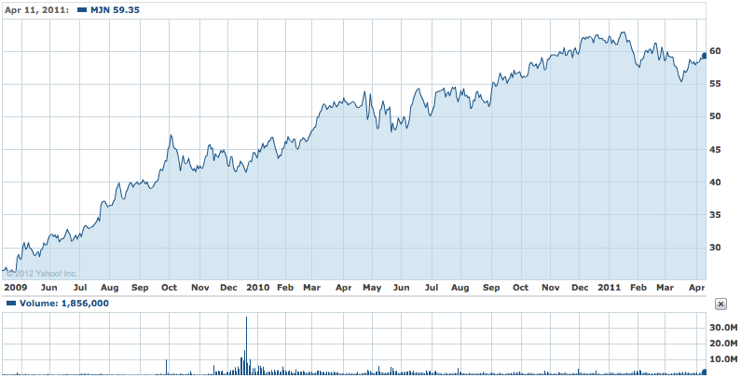
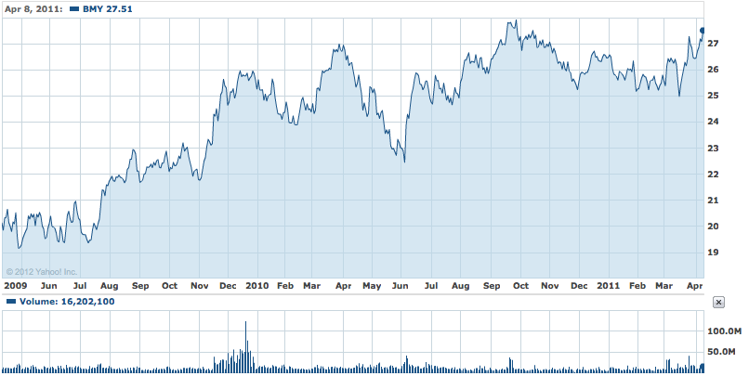

Which stock would you rather own, the parent or the spinoff? Bristol Meyers spun off Mead Johnson in February of 2009. As you can see, MJN (up 124%) in the top chart has handily outperformed the parent, BMY (up 36%), in the lower.

There are many other circumstances that could be referred to as special situation investment opportunities, such as tender offers, spin-offs, mergers and acquisitions, risk arbitrage, and bankruptcy proceedings. I think this is an area where you really need specialized knowledge to succeed. I’ll give you a couple of examples. A company’s stock is deeply depressed. A number of Wall Street analysts have it rated as a sell and are advising their clients that the company is headed to bankruptcy. The bonds of these types of situations often have special promise. Although the equity, the stock piece, might get wiped out, the holders of the corporate debt have a more favorable position. In a bankruptcy hearing dept takes precedence over equity and the bondholders will get paid off before any proceeds are distributed to shareholders. Just how much the bondholders will get paid off is where fortunes are won and lost. You need to have many skill sets to accurately assess this. For example, it helps to have a keen accounting perspective to be able to read the filings and understand what assets there are and what value might be attached to them and any ongoing business value.
Another one of these special situations is merger and acquisition arbitrage: the simultaneous purchase of stock in a company being acquired and the sale (or short sale) of stock in the acquiring company. There are other kinds of arbitrage: liquidation arbitrage, and pairs trading to name a couple but the only one I’m going to get into is merger arbitrage. This is a business you can reliably earn 15-20% in good years.
Mergers and acquisitions have very little to do with the stock market. Corporate takeovers planned with multiyear horizons don’t depend on what the stock market is going to do and in the next month, two months, six months or even a year. It doesn't matter unless they're doing a takeover with their stock then it may matter to an extreme degree and they’ll put in place things known as collars. Merger risk arbitrage is when one public company buys another publicly traded one. There is usually a difference between the purchase price that's announced and what acquisition target stock is actually trading at? Why is that so? There are always uncertainties in corporate takeovers. The deal may be contingent upon financing, a certain amount of due diligence, government regulatory, etc. It will almost always require the approval of the Board of Directors. So as these events happen and the deal progresses and one after another obstacle is eliminated these prices get closer and closer until they coalesce. The difference between these two prices is called the risk premium.
When I worked at Bear Stearns they specialized in this kind of investment and they put out research and projections about the returns and likelihood of these corporate takeovers. One thing they preached and were correct about is if you invested in “risk arbitrage”, you had to buy a basket of these takeovers. Invariably one of these deals will fall apart and instead of having a 15 or 20% annualized return, you will have to a 30 to 50% immediate loss of capital. These risk arbitrage deals have very little to do with stock market so this is a non-correlated return.

An additional kind of non-correlated asset is distressed debt, which is when one company is in bankruptcy. The company in bankruptcy is not going to be immediately influenced by the up-and-down vagaries of the daily stock market. Instead they have bigger issues to worry about, their very viability as a going concern, kind of deal they will be able to cut with the creditors, the amount of equity that may be left or split up amongst the creditors. These are all rather involved and complicated. That's why both distressed debt and risk arbitrage are challenging strategies for individual investors to undertake on their own. This is best done using a brokerage house where there may be teams of specialists dedicated to these issues. There are numerous hedge funds that just specialize in distressed debt or risk arbitrage and they themselves have teams of accountants and analysts people devoted to these particular nuances of investing. These styles of investing can offer great rewards but not much in between. You tend to either be right or wrong but they are uncorrelated returns.

Pros: When all other strategies are not working, special situations can be the ticket to profits. Results of this style are generally not dependent on the direction of the markets

Cons: These situations often require specialized knowledge. Bankruptcy, distressed securities and debt, and takeovers are all difficult fields to accurately assess and generally take teams of experts. Although this style of investing can offer great rewards, it tends to be binary. You are either right or wrong, with little space in between.

Macro Investing

Macro investing is a style of investing that is most closely associated with the hedge fund world. When hedge funds first started, it was difficult to execute an investment strategy based upon a worldview of economic events. That’s not the case today though. A macro investor could take an overall view that interest rates were rising, the economy is heating up, inflation was on the rise, and cost pressure would be great for companies. So in that case an investor might want to short treasury futures in anticipation of rising rates, short the S&P 500 as stocks might fall due to rising cost pressures, and they might want to buy commodity plays based on rising costs. These kinds of macro investment strategies are much easier to do today. There are exchange-traded funds (ETFs) that can mimic just about any kind of worldview that you might have. One benefit in this style of investing, if you are right about the big picture, is you don't have to sweat the risks of any individual company's underperformance. You're not hitching your investing fate to any one company but are playing big and broad trends. For example if you are bullish on the market you might buy one of the S&P 500 ETF's such as SPY and avoid the risk of owning an individual stock that could have an earnings miss or an analyst downgrade.
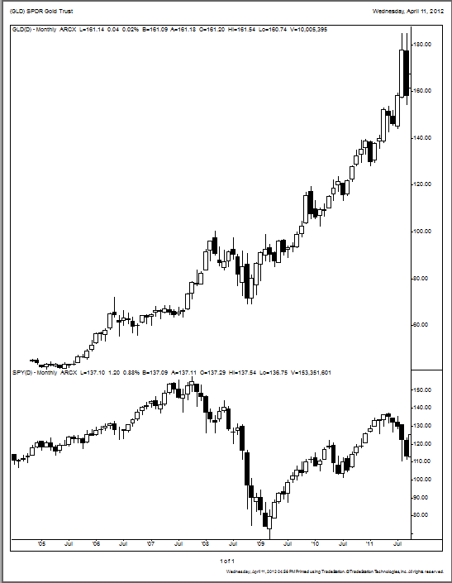
Gold as represented by the exchange traded fund GLD in the uppermost part of the chart window has been a superior performer to the S&P 500 index as represented by the exchange traded fund SPY.

There are disadvantages of to this style of investing. It often uses ETFs with leverage and/or derivatives that may not accurately reflect the impact of market moves. It may even be hard or unfeasible to execute your particular worldview or macro strategy. Many of the inverse ETFs along with the double and triple leveraged short ETFs don’t function as advertised, so buyer beware. That’s one of the reasons its hard to short these ETFs I think. They work horribly and it would be like shooting fish in a barrel if you could short them. It’s generally better to use futures markets and avoid these synthetic bearish ETFs when possible. Also there are situations, which are just impractical or impossible for individual investors to plan for. A good example of this was that many people realized the housing market was set for a tumble long before 2008. Housing prices were rising at an unsupportable rate but there was no obvious way too short a house. Those who figured out how to execute a strategy doing this, such as John Paulson using credit default swaps, made fortunes for themselves and their investors.

A good example of a macro investing style is Gary Schilling’s 2010 book, The Age of Deleveraging. Shilling is a renowned former economist for Merrill Lynch and frequent contributor to CNBC and other business periodicals. The book reflected his worldview that that both individuals and governments had too much debt and would spend the next several years deleveraging from that. The consequences of that would be declining interest rates, tough times for banks, and emerging markets, and a whole host of other investment ideas. Gary Schilling doesn't recommend specific investment vehicles but instead broad ideas and trends. As it turns out in 2011, long term U.S Treasuries were the best investment class, banks were the worst and emerging markets were amongst the worst performing of the world.

So how would the average investor have positioned himself or herself to take advantage of the investment opportunities prescribed by Gary Schilling's worldview? For starters you could have bought an ETF of long-term treasuries, like the iShares Barclays 20 Year Treasury (TLT) that was up 33.60% in 2011. Shorting the banks would have been a no brainer in hindsight but much harder to do with an ETF. For example, Bank of America declined about 58.5% in 2011 and JP Morgan dropped 12 % yet the double-short ProShares UltraShort Financials (SKF) yielded only a 5.5% return.

Pros: The advantage of this style of investing is obvious. If you are right about the fundamentals shifts in macro events you don’t have to sweat the details of any individual company’s performance. You are not hitching your fate with any one company but are playing big and broad trends. For example if you are bullish on the market, you might buy one of the S&P 500 ETFs such as SPY and avoid the risk of an earnings miss or an analyst downgrade.
Cons: They often use leverage and derivatives to accentuate the impact of market moves. It may be hard or unfeasible to execute a macro strategy.

Market Neutral

This strategy attempts to hedge out most market risk by taking offsetting positions, often in different securities of the same issuer. For example, it can be long convertible bonds and short the underlying issuer’s equity. The manager may also use futures to hedge out interest rate risk. Market neutral strategies focus on obtaining returns with low or no correlation to both the equity and bond markets. These relative value strategies include fixed income arbitrage, mortgage backed securities, capital structure arbitrage, and closed-end fund arbitrage
Market-neutral strategies are often employed by taking matching long and short positions in different stocks to increase the return from making good stock selections and decreasing the return from broad market movements. Market neutral strategists may also use other tools such as merger arbitrage, shorting sectors, and so on. A market-neutral position may involve taking a 50% long, 50% short position in a particular industry, such as oil and gas, or taking the same position in the broader market. This strategy is most commonly used in pairs trading. This is when you look at two different stocks in the same sector and buy the stronger stock with the hopes that it will appreciate. The position is then hedged by shorting a weaker stock in that sector. When the sector does poorly, the gains in the shorted stock will offset the losses in the stronger company.
There is no single accepted method of employing a market-neutral strategy. Managers who hold a market-neutral position are able to exploit any momentum in the market. Hedge funds have traditionally been called market neutral as the nomenclature “hedge” means to offset risk. Many hedge funds classify themselves as market-neutral because they are focused on absolute as opposed to relative returns.
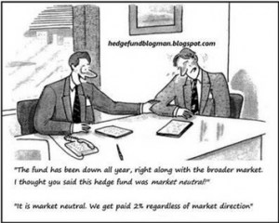
“It's market neutral. We get paid 2% regardless of market direction”

Pros: Proponents of market-neutral strategies balance their longs and shorts in the same sector or industry. By being sector neutral they avoid the risk of market swings affecting some industries or sectors differently than others, and thus losing money when long a stock in a sector that suddenly plunges and short another in a sector that stays flat or goes up. Being beta neutral, dollar neutral, and sector neutral is designed to make their portfolios more predictable by eliminating all systematic or market risk. There is usually low or no correlation to the market. The expected volatility of this strategy is low.
Cons: A lot easier said than done. For example a pairs trade where the manager buys the stock of one company and shorts another in the same industry affords you two chances to be wrong. If it was easy to make money shorting stocks, there would be a lot more people doing it. This is akin to betting a parlay because you have to be right on two or more bets, not just one. A perfectly hedge portfolio might just be the equivalent of staying in cash with the exception of a lot more fees.

Short Selling

This is a style in which an investor sells borrowed securities in anticipation of a price decline and is required to return an equal number of shares at some point in the future. The payoff to selling short is the opposite of a long position. A short seller will make money if the stock goes down in price, while a long position makes money when the stock rises. The profit that the investor receives is equal to the value of the sold borrowed shares less the cost of repurchasing the borrowed shares.
For example if 1,000 shares are sold short at $15 each and then put into that investor’s account. Let’s say the shares fall to $10 and the investor closes out the position. To close out the position, the investor will need to purchase 1,000 shares at $10 each ($10,000). The investor captures the difference between the amount that he or she receives from the short sale and the amount that was paid to close the position, or $5,000.
Essentially, the short-seller will “borrow” or “rent” the securities to be sold, and later repurchase identical securities for return to the lender. If the security price falls, the short-seller profits from having sold the borrowed securities for more than he later pays for them. However, if the security price rises, the short seller loses by having sold them for less than the price at which he later has to buy them. The practice is risky in that prices may rise without bound, even beyond the net worth of the short seller. The act of repurchasing a shorted security is known as “closing” a position or “covering”.
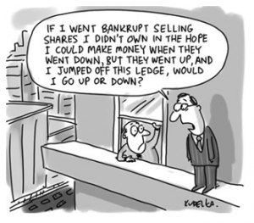
If I jumped off this ledge would I go up or down?

Pros: Stocks tend to go down faster than they go up. If the manager is right about his thesis, big gains can be had. Also short selling provides an investor with both hedges and gains that are not correlated with the market. Managers that tend to specialize in short selling are known for their painstaking, meticulous, and thorough research.
Cons: Since Wall Street is biased toward the long side, there is not much available research on short ideas. Managers must do their own or pay hefty fees to the few off Wall Street firms that specialize in this niche. Short selling also exposes investors to unlimited risks since a long idea can only go to zero and you lose everything you have invested. Stocks, though, can go up in theory an unlimited amount, so an investor is exposed to unlimited risk when a stock moves against you. Often times, the best short ideas, are those that go against the consensus and can take some time with painful paper losses before the gains materialize. Expected volatility of this style is very high.

Option Investing
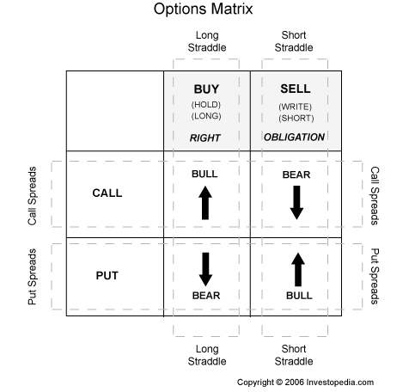

So just what exactly is an option contract? It’s basically an agreement to buy or sell a specific amount of a particular underlying security. Options come in two types, calls and puts, and you can buy or sell either type. This is akin to being able to go both long and short a stock, essentially betting on either the upside or downside potential. That’s the short form explanation. They have all kinds of exotic combinations known as bull and bear spreads, straddles, and strangles, covered calls and naked puts just to mention some of them.
Most investors focus on the two basic types; calls and puts. But the most important type of information I am going to share with you is that most investors lose money on options.
Buying and Selling

If you buy a call, you have purchased the right to buy the underlying equity or vehicle at the strike price on or before the expiration date. If you buy a put, you have the right to sell the underlying vehicle on or before expiration. So why would you do that? In the case of buying a call, you believe you can profit from a rise in price. A put is just the opposite. You hope to make profit by a decline in price. As the option holder, you also have the right to trade the option to another buyer during its term or to let it expire worthless.

The situation is different if you write or sell an option. When selling a short option position, as the writer you are obligated to fulfill your side of the contract if the holder wishes to exercise the contract. When you sell a call as an opening transaction, you're then obligated to sell the underlying vehicle at the strike price. When you sell a put as an opening transaction, you're then obligated to purchase the underlying instrument. Keep in mind, as a writer you have no control over whether or not a contract is exercised. And remember, that exercise is always possible at any time until the expiration date. But just as the buyer can sell an option back into the market, as a writer you can purchase an offsetting contract, provided you have not been assigned, essentially canceling out your outstanding obligation. To offset a short option position, you would enter a "buy to close" transaction.

So where does the profit come in? When you hold a call option, it’s profitable or in-the-money if the current market value of the underlying stock is above the exercise price of the option. A put option is profitable or n-the-money if the current market value of the underlying stock is below the exercise price. If an option is not in-the-money at expiration, the option is assumed to be worthless. Note: 76.5% of all options end up just that, worthless, according to the Chicago Mercantile Exchange.

When buying or selling options, you need to understand several factors that influence the perceived value of the contract. They include supply and demand in the market where the option is traded, what's happening in the overall investment markets and the economy at large, and the identity of the underlying instrument. How does it traditionally behave? Is there an upcoming dividend or stock split? Volatility is also an important factor; since investors profit by gauging how likely it is that an option will move in-the-money.

Pros: Options have a wide variety of benefits when used correctly. They can provide you with the flexibility you need in almost any investment situation you might encounter. Puts can protect your current holdings from a decline in the market, calls can be used to generate income in a flat market, naked puts can be used to buy attractive stocks at lower prices while generating a little income in the process, and options in general are a good (but potentially risky) way to control a large number of shares of a stock without using a large amount of capital.
Cons: Options can be risky! Based on a CME study of expiring and exercised options covering a period of three years (1997, 1998 and 1999), an average of 76.5% of all options held to expiration at the Chicago Mercantile Exchange expired worthless (out of the money). This average remained consistent for the three-year period: 76.3%, 75.8% and 77.5% respectively, as shown in Figure 1. From this general level, therefore, we can conclude that for every option exercised in the money at expiration, there were three options contracts that expired out of the money and thus worthless, meaning option sellers had better odds than option buyers for positions held until expiration.

Technical Trading

Technical Trading and Market Timing: This style of investing may allocate assets among different asset classes or different securities depending on the manager’s view of the economic or market outlook. Portfolio emphasis may swing widely between asset classes. Unpredictability of market movements and the difficulty of timing entry and exit from markets add to the volatility. Technical traders may pay little attention to the fundamentals of a company. They believe that everything you are likely to know about a stock is incorporated into its price already and the future course of this price is best divined by looking at its chart. This is a controversial style of investing and its’ critics describe it as akin to using a Ouija board to predict stock price movements. They believe that it is a useless waste of time to analyze charts in the hope of predicting future price movement from past patterns. You should keep in mind though that most Wall Street firms have chartists on their payrolls. Even if you don’t believe in charts, you should keep in mind that others do and are influenced by them. There are thousands of traders around the globe glued to them ready to fire off orders based on their interpretations.
Amongst technical traders there are a couple of distinctions you should keep in mind. The time frame, the interval in which you work, is really the determinant of the technical trader’s style of investing. A day trader will always go home flat each day. They won’t hold a position overnight but instead try to profit from the swings in price during the day. Day traders scalp small amounts of profits and generate enormous commissions relative to the dollars they keep for themselves. A swing trading position is typically held for a few days to a few weeks. Both of these kinds of technical traders can go long or short. Contrast this with a buy and hold strategy or Buffet view point that his holding period is forever.
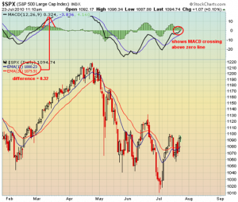
The moving average convergence indicator is crossing the zero line and is considered a buy signal

Pros: Even a sound investment decision based on fundamentals can give a mediocre result if the entry and exit points of the investment are not fortuitous. Proponents of technical analysis claim it maximizes the returns on their investment. It may alert them to momentum waning and give them the opportunity to exit a stock and protect profits before they evaporate. In the kind of market we have had for the last decade trading profits have often been the only source of profits
Cons: In the absence of news or volatile stock market conditions, it may be possible to predict short term price movements but no matter how good a technical trader may be at chart reading, one piece of significant news is going to blow apart any chart prowess they might possess. . Also a sector movement can overwhelm an individual chart pattern. For example, Intel may have a favorable chart pattern, but a general decline in the semiconductor index or ETFs can bring Intel down with it. For these reasons and others many technical traders avoid individual stocks and play market indices and ETFs where they are least likely to get ambushed by the news. Volatility is high.

Emerging Markets

Another area of investing that was particularly popular over the past 10 years was emerging markets. It’s almost incorrect to call it a style other than the fact that people poured into it with abandon creating a category in and of itself. For a decade the fund flow into emerging markets particularly the BRICs (Brazil, Russia, India, and China as a good case was made that these markets were fundamentally better valued than developed ones. China in particularly attracted the lion’s share of capital and energy.
As measured by monthly trailing price/earnings ratios, emerging market stocks are no longer cheap relative to the U.S. stocks, as they were in the early part of this decade. After a decade of strength, stocks in emerging markets lagged those of developed markets in 2011, particularly the U.S.

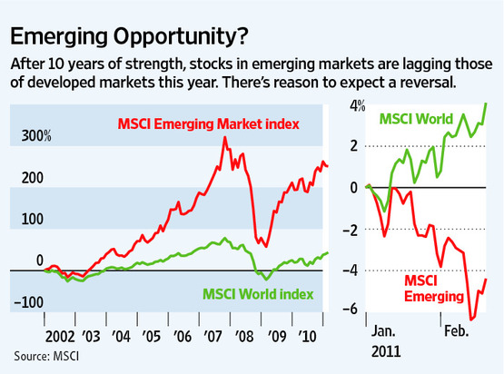

In recent years emerging markets have outpaced developed ones

As it turns out emerging and developed markets aren’t that dissimilar. The world is getting smaller and that’s showing up in greater correlation. Emerging markets may prove to be just a higher beta version of our own market. Another one of the cons of this style of investing is emerging markets are not as transparent as developed ones. There’s also more political risk associated with them.

Pros: Over the last decade emerging markets have outperformed the S&P 500. They may provide growth opportunities superior to more established ones.
Cons: Short selling is not permitted in many emerging markets, and therefore, effective hedging is often not available. Correlation between all markets both emerging and developed is increasing as the world is becoming increasingly globalized. Emerging markets are not as transparent as developed ones. Political risk is also greater. Volatility is very high.

The Black Box: Money Goes In, But Doesn’t Come Out

Black box investing is a style based on computer algorithms that predict short term-price movements. These price movements can be about anything but they are generally widely traded derivatives on popular indices. Popular ETFs like the SPY or the e-mini S&P 500 futures provide plenty of volume to buy and sell based on any combination of computer signals. A benefit of this system is that they are supposed to work in bull and bear markets with fabulous returns. You don’t know how they work, hence called “black box”. Just follow the buy and sell signals and you will make money, or at least that’s how they’re advertised. Reality is they don’t work at all or at least none I know of have. I can’t imagine that if you had a system that worked as well as promised, people would advertise it. Why bother trying to sell it if you can print money?

Pros: When they work, these strategies require little work or input on your part. Generally you can just sit back and watch the money pour in.
Cons: You are not in control, which means you better have a lot of trust in the system or an amazing form of risk management to be able to sleep at night. Not to mention that almost all of these “systems” you see peddled on TV commercials DO NOT work. The forms that do work are generally extremely difficult to impossible for the general public to utilize. The volatility for these kinds of black box strategies is very high.

Every Style Can Work, But You Can’t Work Every Style

The market is a balance, a constant psychological tug between two polar opposite emotions- fear and greed. The tension between these two feelings is the source of the daily pulse of the market. Selling leads to more selling as crowd behavior takes hold. Everyone jumps in and on days of unanimous opinion, we witness capitulation. When everyone throws in the towel, it’s usually the end of the downdraft, at least in the short-term. It’s often best seen with a big price reversal, where the markets probes or makes new lows and then reverses this behavior during the day. The following day or days are often periods of rapid price appreciation.

In this phenomenon, players can hardly control themselves. The frustration of missing the train can easily outweigh the pain of losing money. Stocks move inexplicably higher only to find more buyers desperately trying to get on board. In fact, there is a school of investing in part based on this phenomenon known as momentum investing.

Now it’s easy for a trader or investor to fall victim to both extremes. In fact I would venture to say that oscillating between extremes is the natural state of being and finding the equilibrium; the middle zone between fear and greed is the exception to human behavior, not the norm. The investor who can control his emotions and live in the calm middle zone will be far more successful than the average player living on the edges of fear or greed. The failure to understand how this behavioral psychology affects the market is often behind the passionate belief that you can’t time the market. If you can control your emotions, you will be way ahead of the game.

Identifying the investment style that will work best with your emotional makeup can be difficult, and you need to put some thought into it. Using a system from Mark Wilensky’s book Inside Sales Management, I’ll provide a frame of reference that will allow you to identify the type of investment style you relate with. For the past thirty years, Mark has trained successful sales people across a broad spectrum of industries. From finance professionals to software engineers, he has utilized a simple system that provides his students with a framework of how different types of personalities react to the same situation. Now sales is a different game from investing, but identifying your strengths and weaknesses are essential in becoming successful in any role.
This section is designed to help you do two things: identify your personality type and associate that type with a suitable investing style. While this is a simplified version of Mark’s system, it works. As we describe the four personality types, Bull, Owl, Lamb and Tiger, keep in mind that nobody exhibits only one type all the time—everyone is a combination of all four.

Bulls

First let’s consider the Bulls, also referred to as dominant directors or ‘aggressives’. When identifying a Bull, here are some points to keep in mind:
1. They are precise, organized, and disciplined.
2. They keep focused on business—primarily their targets and goals.
3. They demonstrate bottom-line results and benefits with associated costs.
4. Phrases like “return on investment” and “bottom line” get their attention because that’s the way they process things.
- They tend to have a black and white view of the world.
- They like to measure by previous results; a track record should be strong and relevant.

Owls

Because they live in their Adult ego state, Owls are the cautious thinkers, the ‘analyticals’ of the group. They arrive at decisions through logic in a step-by-step process, with little emotion and lots of data. Here are some points to keep in mind when identifying Owl behavior:

- Owls like to be briefed in a rational, logical, systematic, and even predictable manner.
- They require valid evidence to support any statements made to them. Owls dislike and discount sweeping generalizations and exaggerations.
- Owls want facts, data, and more facts so they can arrive at their conclusions. After weighing all the evidence and checking it several times they will come to a conclusion. They don’t like to be rushed to make a decision.
- Owls are practical and risk adverse. They look to save time and money.
- An increasing number of owls are slowly venturing into the markets independently. The high-tech boom has seen a migration of Owls from the sidelines or from their financial advisors to using discount brokerage services and trading on their own knowledge. They may spend a lot of time developing simulations, projections, and investigating details of potential strategies.

Lambs

If you think you are a Lamb, you’ll identify with the following points:

- Despite being open to influence, you don’t want to be stampeded into a decision without understanding how you arrived at that conclusion. You prefer not to jump to conclusions, or brush over details. Your approach is soft, steady, and risk averse.
- Rather than debate facts, they would rather hear how someone feels about the situation and why, even with details.
- Lambs sincerely care about their concerns and ideals more so than any other personality type. Investment solutions should address the effects it will have on every party involved. Socially conscious investment vehicles would appeal greatly to a Lamb
- Because Lambs don’t like confrontation, they may not raise many objections and they don’t like pressure. While you may be open and receptive, you don’t want to be pushed over the cliff.

Tigers

As a Tiger, you’re a natural extrovert. Often described as an interactive socializer, you can gather a crowed around you to hear your well-told stories. Naturally, you enjoy a good story yourself, including ones about investment opportunities. If you think you’re a tiger, then the following points will be familiar:

- Stimulating conversation appeals to them. They like to talk, especially about themselves and their own investment theories.
- Success stories, hot tips, and yesterday’s winners will appeal over more effectively than detailed, logical analysis.
- Tigers sometimes need help at every step to take care of details, which they tend to overlook.
- They prefer open-ended questions when discussing their goals and dreams rather than specific questions they have to try and fit their answers to.
- Many Tigers have a short attention span—they may be interested in an idea, but not for long. This may be one reason why they tend to be more of an impulse buyer than other personalities. They can buy a good story, told by a good storyteller, and later regret it.
- Tigers may jump into an investment without adequate preparation or analysis. They often seek shortcuts and neglect the risks associated with such ventures.

When considering yourself in this context, you should ask, What personality type am I? Ask these question first, before you decide on whether you are mostly a Bull, Owl, Lamb, or Tiger. After you’ve identified your personality, it’s time to pair it with an investment style. Of course, nothing is black and white, just as no individual is purely a Bull without Owl, Lamb or Tiger characteristics.
Why is it important to find the right style? Lets examine an Owl for this example. We know they are detail oriented, logical, and love precision. They are also slower paced, cautious, and tend to avoid risks. Based on these characteristics, would an options based strategy that involves big swings in the value of their investment be suitable for them? Of course not. Owls would feel more comfortable researching and investing in municipal bonds or index funds than a volatile options strategy. Investing is no fun when you can’t sleep comfortably at night, and chances are your frustration will be evident in your returns. Owls stay up all night to hunt, not to worry about their investments.
Just because a slower paced, conservative style works well for Owls doesn’t mean that it will be right for everyone. Would a similar approach work well for a Tiger? Someone who is risky, fast paced, and not detail oriented would find an Owl’s approach to investing boring and unchallenging. A Tiger would probably prefer the rapid price swings of emerging markets or growth stocks.
The chart below is designed to help you identify what styles of investing will fit best with your personality. It’s important to remember no one person is 100% Bull or Owl – we are all a mixture; we are all B.O.L.T.s. This means that no one style of investing will be a completely perfect fit for its corresponding personality. Consider this as a way to guide yourself toward a style that will increase your probability of being able to sleep at night while maximizing your investment opportunity.

Let’s start with the top left quadrant marked Owl. We know Owls are contained, reserved, logical, and detailed. They are also slower paced, less competitive, cautious, and risk adverse. Based on these characteristics, an Owl would find the precise, structured, process-driven aspect of technical trading appealing. The slow, steady appreciation of long-term value stocks would also be an appealing aspect to a low risk, low volatility personality. A market-neutral strategy, although challenging, could also be used to reduce volatility.
Moving on to the Bulls, we know they are logical, proof seeking, precise, and a clock-watcher. They are also fast paced, competitive, assertive, risk seeking, and impatient. A strategy like technical trading would probably drive a Bull a little crazy considering the attention to detail required to execute. They would rather look at investing on a macro level, which would cater toward their love of the bottom line and logical though process. They would also enjoy the level of risk and decisive nature of short selling since it requires a simple and definitive position on a company.
Now lets look at the Tigers. They are intuitive, flexible, non-detail oriented, and easily interested. Based on these characteristics, a Tiger would be drawn to both emerging markets and special situations. Tigers like to be entertained and go with their gut. They like the fast paced, risky nature of these investment classes. The next hot IPO would be appealing to a Tiger.
Last we have the Lambs. The most important thing for them is to avoid risk. Consequently they move at a slower pace, aren’t as detail oriented as Owls, and are intuitive like Tigers. Lambs want to shy away from volatile, complex investments that appeal to someone with a more aggressive nature. Exchange Traded Funds are a good solution for Lambs. They provide exposure to the market without the risk of individual stock selection. Growth funds are also appealing based on their longer-term time horizon and diversification. This also applies to growth and income investments. They provide both immediate income and opportunity for appreciation at the same time.
A final thought on investing and personality styles. Just as a committee benefits from multiple perspectives, investors can also gain from sound strategies that might not feel natural at first. An investor who’s a Tiger might avoid major losses if his advisor offers an Owlish point of view. And an investor who’s an Owl could be missing out on potential large gains that a Tiger advisor might offer. We tend to be creatures of habit. A change of habit can be a profitable move, especially when it’s based on sound and proven investment strategy.

Two Famous Investors – Two Different Styles

So now that you’re ready to put the most profitable style into action and start making some money, stop and ask yourself “so what style works best”? Can’t think of an easy answer? Good, because there isn’t one. No one style is inherently better or more profitable than the other. The success of your investment situations is derived from your ability to maximize the effectiveness of each style, not picking the style that seems to be in favor at the moment.
For example, lets say you take two opposite personalities: Jen, has happily worked as an assistant librarian for the past 14 years and Don, a 22 year veteran sergeant of the Baltimore City Police Department. Can you tell which categories these two individuals fall under? Good. Now picture a market that’s been on a bull run for several months, seemingly unable to correct downward for more than a day at a time. People are wary, even looking for a large sell-off looming in the not-so-distant future. Seems like a perfect scenario for a short seller, right? While the economic environment might completely cater to Don’s bullish persona, think of what would happen if a lamb like Jen decided to change her strategy. Who knows the extent of the outcome, but I can almost guarantee that many stressful, sleepless nights will ensue.
In many ways you won’t find two polar opposites of talent than Peter Lynch and Warren Buffett. Buffett invests in a concentrated way, often saying things like the odds of your tenth best idea being as good as your first is low. Or you should treat investing as if you had a punch card and you could only put so many holes in it and when you used it up, it was gone. Lynch invested in hundreds of stocks and liked to visit the physical locations and kick the tires. Buffett is famous for staying home in Omaha. But when I go over many of these items on Lynch’s checklist, it seems like vintage Buffett. Dull, uninteresting, people have to keep buying it, the company is buying back shares are all things Buffett could have written. Their returns through out a comparable period of time were also similar. From 1977 until 1990, the Magellan fund averaged a 29.2% return. During the same period, Buffett’s investing vehicle, Berkshire Hathaway averaged 20.06%. Two different investors but similar results produced by two different plans with much in common.
The most striking thing about both investors and their approach to the game of investing is that it keeps changing and is far more complex than meets the eye. The Magellan Fund has never been as strong and consistent a performer after Peter Lynch left the helm. There are many postulates as to why this is the case. I am going to introduce a new one. Few believe Berkshire will be the same after Buffett. In fact those trying to imitate Buffett’s style now have paled in comparison. I believe that just like the two investors shared some things in common, one thing they shared that the market has failed to appreciate is that both investors constantly changed, they evolved and their styles of investing encompassed many and broad asset classes. Buffett has bought everything from blue chip consumer stocks to junk bonds to even writing massive amounts of index puts. Peter Lynch bought it all: slow growers, fast growers, stalwarts, cyclical, asset plays and turnarounds. Even though he owned hundreds of stocks in the Magellan fund, he maintained a plan.

Peter Lynch’s philosophy can be broken down into five lessons to live by, and can be applied to almost any strategy you decide to trade with:

Invest In What You Know- Peter is obviously a strong proponent of investing in companies you know and understand. The closer you can put yourself to the information source, the further ahead you are of the Wall Street analysts who drive the market. Analysts have to wait for opportunity to show itself in the numbers, so be ahead of the numbers.

Can You Explain What You Are Buying?- Just like when you pick a strategy, you need to understand how the process works. If you can’t explain how a company makes money, then you aren’t following the first rule of investing in what you know. And if you are going to invest in what you don’t know, you might as well be buying lottery tickets.

Don’t Waste Time Predicting Things You Cannot Control- The investment world is flush with some of the brightest, most intelligent minds in the world. Unless you think you’re smarter than these individuals who have spend their entire life focusing on specific areas in the economic environment, leave the predictions to the professionals and focus on lesson one. If the environment determines the soundness of your investment, then maybe your idea wasn’t all that sound to begin with.

Find Fast Growth In Slow Industries- Peter often ignored the hot new industries in favor of the mundane, even lethargic ones. His philosophy suggests that if you can find a company who can persevere beyond its peers in the face of a sector headwind, you have found a resilient winner. The more handicapped the company is by operating in a boring industry, the easier it is to identify ingenuity on the behalf of the management.

Find Them Before Wall Street Does- Now before you say this is impossible, it doesn’t mean you have to scour the earth for every new startup. Look at public companies who’s institutional ownership is relatively low in relation to their peers. If a stock shows 80-90% institutional ownership, chances are the analysts have already beat you to the punch. Also consider the above example. Hanes was already a widely known company, but Peter was able to identify opportunity through using common sense, not some complex valuation metric or formula.

Have a Plan

By understanding the various styles of investing on Wall Street, you will have a better idea of when to play and how much to invest. If there are opportunities in defensive stocks versus growth stocks or an entire asset class like bonds as opposed to equities, you can adapt your style
Investing in the stock market has been called a zero sum game. For everyone making money, someone is losing it. Look for the good odds, search out the investment opportunities you like and understand. Find your edge. Like the old saying goes, “If you sit down at a game of poker and you don’t know who the chump is, then the chump is you.” Take advantage of these different opportunities, bull or bear, growth or value, bonds or stock.

“Bear markets begin in good times. Bull markets begin in bad times.”

I haven’t been able to conclusively cite the origin of the above quote, ‘Bear markets begin in good times. Bull markets begin in bad times’ but undoubtedly it was from an investor who survived the bear market. The good news is that you can make money in any kind of market. You can profit from the market rising or going down. You can even make money in a market that doesn’t move at all. But what you can’t do is make money without a plan. Ultimately you will only be successful by trading on your own ideas and style but that is going to come with time. Read everything you have the appetite and patience for but at the end of the day you will have to set down a plan either in writing or in your head. Stick to it. Follow it religiously. Any plan even a highly flawed one will be better than no plan. No matter what you ultimately come up with as your investment plan, it’s going to have to incorporate these following principles.

Mute The TV Volume

Keep your eyes open but form your own opinions. Listening to pundits on CNBC and Bloomberg has cost me money and caused a lot of anxiety. The best gurus on TV are right less than half the time. I can’t imagine any other occupation where you can stand up and act like you know exactly what you are talking about and be continuously wrong. Before I take anyone’s investment advice seriously, I want to see his track record. Few have a better one than my own. That saves me a lot of time right off the bat.

And if you think Warren Buffett, the greatest investor of all time, thinks of investing and gambling as two disparate trades, think again. “The market is a racetrack too,” he is quoted as saying in The Snowball. Peter Lynch in his 1989 bestselling book, One up on Wall Street, devoted the third chapter, Is This Gambling or What, to this subject. It can be summarized in his words, “To me an investment is simply a gamble in which you’ve managed to tilt the odds in your favor.”
So how do you tilt the odds in your favor? After all if you knew the odds it wouldn’t be the investing game. When you walk into a casino in Vegas, you know that every game inside has odds favoring the house. Some games like blackjack offer better odds than let’s say slots, but statistically, you know that every single game has a house advantage.

“If you don't like the odds, don't bet.” Jesse Livermore

The first way you begin to bend the odds in your favor is to have a plan.

Electric Cocktails- Technical Analysis Simplified


“You see I can predict this stock went down!”

The day-to-day movements of the market are a combination of emotion, fact, and rumor served up on a global platform. Human emotions, news, and talking heads are all mixed up into an electronic cocktail of red and green lights. There are two ways of making some sense out of this. There is the fundamental approach which analyzes a company's earnings, their debt to capital ratio, their price-earnings ratio, cash flow, capabilities of management, and a whole host of other quantitative and qualitative measures in order to determine a company’s current and future prospects. Then there is the technical side of analysis that looks at the price of the underlying security in relation to prior prices and volume.
Technical analysis takes a completely different approach than fundamental analysis. It doesn't care one bit about the "value" of a company or a commodity. Technicians (sometimes called chartists) are only interested in the price movements in the market and will often remark that all news and fundamentals are already reflected in the patterns of the charts. I love them because you need to have someone in the market dumber than you. The old saying about sitting down at a game of poker and if you don’t know who the sucker is, then the sucker is you. Well, anyone that believes that everything is in the charts is the sucker. Don’t get me wrong. I believe in charts but one piece of news has the potential to blow apart the best of chart patterns.

Technical analysis is controversial. There are a lot of very successful investors that believe charts are complete nonsense. They’re successful in spite of themselves. Every major Wall Street firm employs technicians today. There are dozens and maybe hundreds of technical indicators. Fortunately most of these are worthless so you don’t have to expend a lot of brainpower understanding arcane math formulas or bizarrely named chart patterns. I only look at three technical patterns and that’s the result of years of running computer programs that back test dozens of these indicators on thousands of different securities. Lastly what I’ve learned is borne out from experience, the school of hard knocks, whatever you want to call what happens when you start using real money. Believe me using play money or simulated trading accounts is nothing like the real world of watching your precious nest egg dissolve in front of your eyes when trades go against you. It reminds me of heavyweight champ Mike Tyson’s comment, “they all have a plan until they get hit.”

I’m not going to waste your time and explain a bunch of technical analysis indicators you will never use and of limited value. Instead, lets cut to the chase. The three tools I am sharing with you are all you need. I daresay anything more will even hurt your performance. Now let me say something totally heretical. I don’t believe that two of the three tools even work! Yes, what I am telling you to learn is total nonsense. BUT IT WILL MAKE YOU MONEY AND SET YOU APART FROM THE LEGIONS OF PEOPLE STUMBLING BY. Look at it this way. If enough people believe something to be real, it will appear real for a while. Have you head of The Emperor’s New Clothes?

I decided against writing a summary of technical analysis. Others have already done it, far better than I could. Check out John Murphy’s Technical Analysis of the Financial Markets: A Comprehensive Guide to Trading Methods and Applications if you want to learn more. TradeStation’s own dictionary of technical analysis technical indicators is an incredible online help platform that provides a brief explanation of each indicator. While it doesn’t go in-depth into the formulas that calculate them like Murphy does, it provides fantastic illustrations of how they look and work in their particular platform. One of the true marvels of computing is that complex math formulas can review years of daily data of the high, low, close prices of stocks and render instant plots of whatever you can dream of. This was one of the first incredible usages of personal computers probably right behind spreadsheets, word processors, and databases. But the bigger question is does technical analysis work?

Technical Analysis is Always Right... Until its Wrong

Does it predict future price movement? Does technical analysis work? You would think that a discipline so heavily dependent on math and computers would have a simple answer to this question. For several months I routinely and religiously ran a program that optimized dozens of technical indicators against the universe of S&P 500 stocks. I was trying to determine which indicators tracked better. Do some technical indicators work better than others? I think most technicians would say yes without hesitation. If you believe that some indicators can predict future price movement better than others, then there’s plenty of off the shelf software that can scan historic price action, backtest an indicator, and provide you with comparison reports.
Every day I used to run a software program, comparing the entire S&P 500 against a universe of technical indicators. Astoundingly enough many stocks showed reliable patterns. Some indicators DID work better than others. There was no doubt about it. It was quantifiable, repeatable, and visible right in front of your face. However, just because an indicator worked well for some period of time, there was no assurance that it would continue to work well. If you are using raw computer power to find patterns, you will. Some indicators worked better than others on certain stocks until they didn’t. My proof was my money line. It wasn’t growing. I think backtesting is a waste of time. You can only buy or sell now or sometime in the future, not the past. When someone comes up with a future testing solution, I’ll listen.
A broken clock is right twice per day and we all know that’s worthless. Nonetheless, I do believe completely in technical analysis. It’s just that most of the indicators are worthless in my opinion. It’s ironic to me that I don’t believe in 90% of technical analysis but the 10% I do believe in holds a powerful sway over my thinking about markets and making money in them. So instead I’ve come up with a preferable solution. I’m only going to talk about the ones that either have some predictive ability or provide some trading advantage: the ones that work.

Support And Resistance

Support and Resistance are two of the most closely watched and utilized technical indicators. Although subjective at times, identification of these key indicators is an essential ingredient to successful technical analysis. Even being aware of their existence and location can greatly improve your forecasting and analyzing abilities. Support and resistance are price levels at which either supply or demand for a security is often perceived greater than the other.. Stocks will often exaggerate their movement at these key price junctions .

Support: is the level at which demand is thought to be great enough to prevent further declines in price. Support is determined by drawing a line connecting the low points (the valleys) on a stock chart. As a stock price declines, investors are mindful of these price levels. It’s almost as if there was some kind of memory inherent in a stock. Human behavior follows certain predictable patterns much like memory metal.

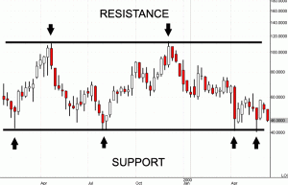

Resistance: is the price level at which supply is thought to be great enough to cap any further appreciation. It’s the reverse action of support. Resistance is determined by drawing a line connecting the high points (the peaks) of the stock price. Stock price action exhibits unusual activity as it struggles to exceed the peak price. Often times this market action is explained by investors who are waiting to get even and dump the stock.

Watch for stocks reaching their support and resistance levels. Keep in mind that prices may briefly go beyond your established support and resistance levels so it is a good idea to have a price “zone” rather than a specific level. Once these “zones” are broken the relationship between supply and demand has been altered. Broken support levels often times become the new resistance levels and vice-versa.

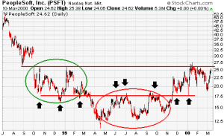
As PFST broke through it’s level of support, it became the new resistance zone.

In fact, you can make a logical argument that buying a stock after it makes new highs is the best time. This style of investing is often associated with “momentum investors”. Sudden spurts in volume are followed by quick price appreciation when stocks “break out”. There are numerous stock screening tools designed to rapidly identify this occurrence in real-time, although it may be a better strategy to trade against this behavior and short them. Following crowd behavior is usually the wrong thing to do.

Moving Averages: These are also helpful when used along with support and resistance. The moving average is simply a line chart that shows the average value of a security over a series of periods. They do not predict the price direction; rather they define the current direction with a lag, because they are based off of past prices.

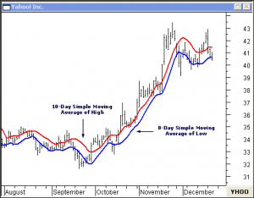

Moving averages can exhibit the same effect as support and resistance when price approaches them. But unlike regular support and resistance levels, they do not remain at one stationary level and move on your chart. Simple averages help form the building blocks for many other technical indicators.

Just like support and resistance, stocks exhibit short-term predictable behavior at the 50 day and 200 day moving average lines. These lines drawn by the computer become support and resistance lines just like the lines drawn from peak to peaks and valley to valleys. Although you should never make an investment solely based on a technical indicator, having an understanding of these simple concepts can greatly improve your results..

In order to do that you want to be sure you're using the moving averages that are the most popular ones. In that case it would be the 50-day and the 200-day moving averages. Since the primary goal of this exercise is to see what other people are seeing, you should look at what other people are looking at. Draw two lines connecting the values of the moving average along the high points and the low points. The low points of the moving average will be your support and the upper limits of the moving average will be your resistance.

Oscillate This

There are a number of technical indicators under the category of oscillators. They are all interpreted pretty much the same way. We are going to concentrate on the most popular one, stochastics. After all, the reason we look at just the 50 and 200 day moving averages is the same reason we look at stochastics. This is the oscillator most stock chartists are looking at.

The good news is that all of these different oscillators, stochastic, moving average convergence divergence (MACD), RSI, etc. work the same way. The stochastic oscillator is interpreted as a sine like wave fluctuating from below the 20 level, which marks oversold territory to above the 80 band that marks the overbought boundary. The idea behind this is that when the indicator rises above 80 the stock is overbought. Now stocks can stay overbought for long periods of time. In fact the biggest winners will stay overbought.
When the oscillator leaves the overbought level and crosses below the 80 threshold, this is the time to sell the stock. The reverse is true. When the stock leaves the oversold area crossing the 20 level, that’s the time to buy. The illustration below demonstrates this perfectly. Buyer beware, few times in real life does it work so handily.

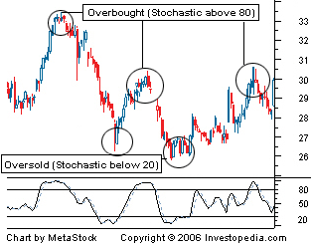

Divergence- My Favorite Technical Indicator

We’ve spent some time discussing technical indicators that I don’t really believe have any real predictive power. Now I’m going to tell you about an indicator that works. This is divergence. Most oscillator indicators just track the direction of the underlying security. If a stock is rising, the oscillator will generally follow suit. When the stock falls in price, the oscillator will fall with it. Divergence is explained when this connection between the indicator and underlying stock is broken.

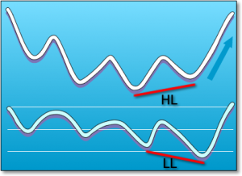

Divergence is a move in the price of an asset not confirmed by a comparable move in the applied technical indicator. For example, in the illustration HL price begins a move upward yet LL indicator is actually moving in a different direction.

Divergence is the most predictive of all the indicators. It will be early more often than not. Early can be very painful, though. An often-repeated saying on Wall Street is “What’s the difference between being early and wrong?” There isn’t one.

That being said let me show you how I interpret divergence. First of all I only look at a version of Wilder’s relative strength index when I’m examining divergence. Developed by J. Welles Wilder, the Relative Strength Index (RSI) is a momentum oscillator that measures the speed and change of price movements. Before we get too far into this, let’s rehash the popular version of what this indicator does because I don’t use it in the way most people do.
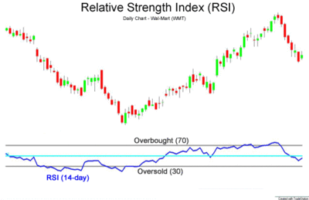

Relative Strength Index 14-period

The RSI is presented on a graph above or below the price chart. The indicator has an upper line, typically at 70, a lower line at 30, and a dashed mid-line at 50. Wilder believed that when price moves up very rapidly, at some point it is considered over-bought. Likewise, when price falls very rapidly, at some point it is considered oversold. In either case, Wilder deemed a reaction or reversal imminent.
The level of the RSI is a measure of the stock’s recent trading strength. The slope of the RSI is directly proportional to the velocity of a change in the trend. The distance traveled by the RSI is proportional to the magnitude of the move. Wilder believed that tops and bottoms are indicated when RSI goes above 70 or drops below 30. Sound familiar? In between the 30 and 70 level is considered neutral, with the 50 levels a sign of no trend. According to Wilder, stocks can stay overbought or oversold for extended periods of time. For those of you that want a formula and further explanation of how Wilder’s RSI is calculated and graphed, StockCharts.com has an excellent explanation.
I pay no attention at all to this traditional interpretation. Oscillators generally track the movement of the stock and if you look hard enough at any of these indicators, you can see some recurring patterns. The test is can you accurately predict future price movements well enough to make any money? With the exception of divergence, I don’t believe you can.
What works well for me is that Wilder believed that divergence between RSI and price action is a very strong indication that a market turning point is imminent. As I discussed above bearish divergence occurs when price makes a new high but the RSI makes a lower high, thus failing to confirm. Bullish divergence occurs when price makes a new low but RSI makes a higher low.
Let’s illustrate how this works with this chart of Apple. I use Trade Station’s popular charting software and a proprietary version of Wilder’s RSI that I had coded in their programming language, Easy Language.

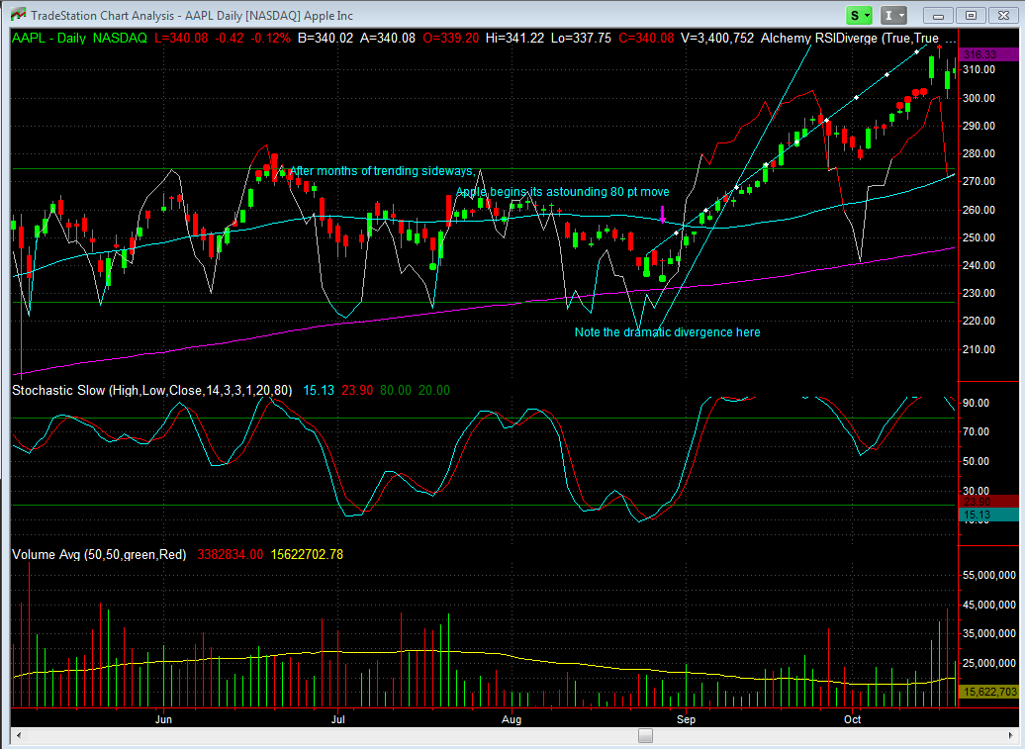
Wilder’s RSI divergence on Apple

As you can see, in this screen image, Apple Computer’s stock appears to be range bound for several months between April 2010 and August 2010. Then on August 25, and then again on August 27th my indicator fired off an alert indicating divergence. It fired off a very early alert a month earlier that created brief profits before being reversed. As you can see from the chart, there is a very dramatic divergence between the price action which is still trending down or flat and Wilder’s RSI which is beginning to rocket up. This is a very clear bullish divergence and led to a dramatic 80-point rise in the stock before exhausting itself.
Starting though around October 18th, Apple begins to show dramatic bearish divergence. This was an early warning for traders to exit or even short sell the stock, although, I wouldn’t want to short a stock with such obvious strong prospects. At a minimum Apple was dead money for a month or so after this signal.

Expanding the chart to view the price action in 2011 shows two more divergences, another bearish one and then a positive one. Actually there are several bearish signals but like I mentioned earlier, stocks can stay overbought or oversold a long time. In fact strongly trending ones will.

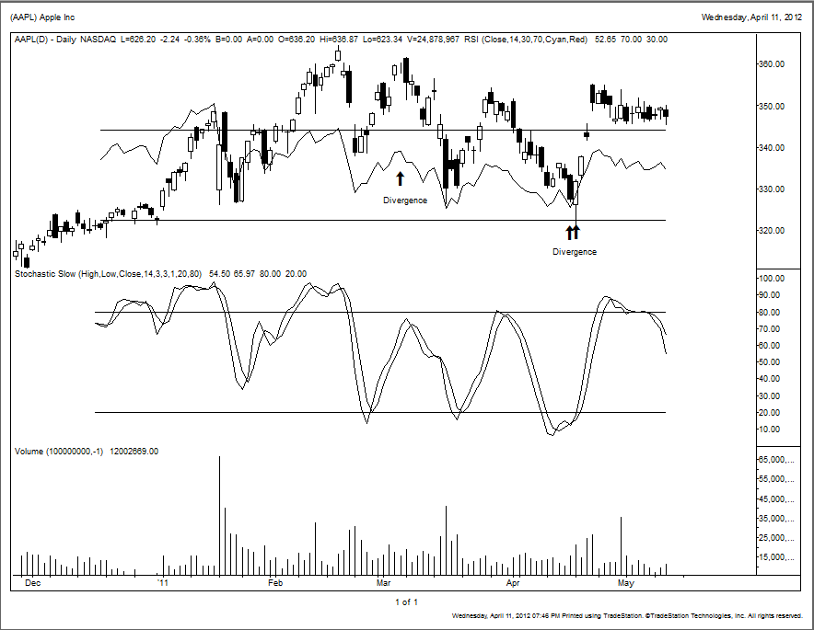
Diverging Wilder RSI line portends sell off and rally

As you can see when Apple topped out on March 4th, its RSI line had already turned down. This was a classic bearish divergence. Then for the first time on April 15th and April 18th, Apple showed clear bullish divergence both in the RSI line and on my indicator software. I blogged about this widely in fact as Apple rewarded investors with a quick 20-30 point gain depending on the entry.

A couple important points to remember:

- The period you set your indicators too will have a tremendous impact on your outcomes. I use a short time period on Wilder’s RSI indicator (just seven days). I’ve found that’s what works best for me with my style of investing. Others may find better results with different periods. Wilder himself suggested a 14-day average. I also use daily charts. Weekly charts, monthly charts or even 2-minute charts will all likely have very different results.
- RSI divergences work best in markets that are range bound. Stocks that are breaking out or breaking down can trend in a particular direction for longer periods of time and make these types of indicators less useful.

Technical analysis is just one piece of the picture. A slight edge in investing can yield enormous results. But don’t fall victim to the dogma that all known and future expectations are already revealed in the stock’s chart. As I mentioned before, one piece of news can often blow apart the most attractive of chart patterns. It’s only valuable when combined with other information. In the example below I’ll show you how I used RSI divergence in conjunction with fundamental analysis to make outsized gains.
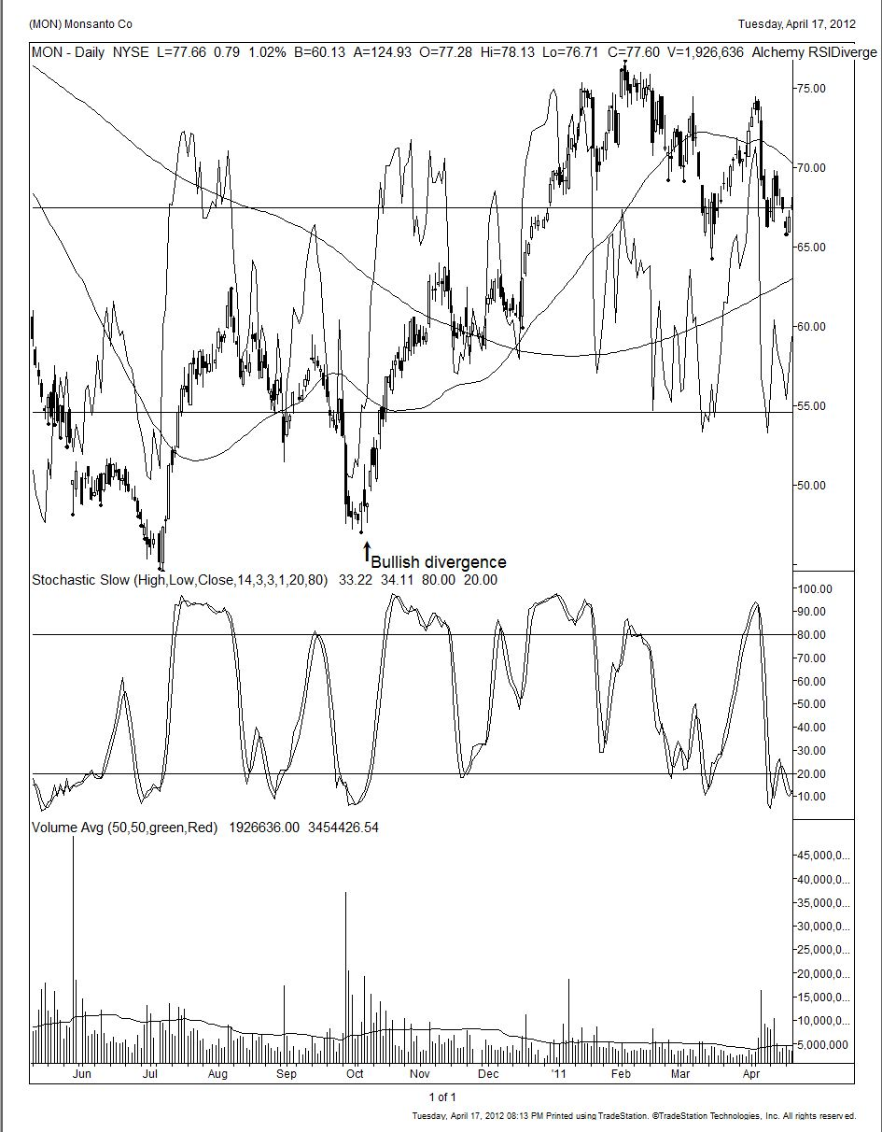

This example, Monsanto, was our most profitable stock trade of 2010. We just didn’t buy it because there was a divergence in the chart. That was simply the first stage of the process. We also knew the Monsanto story. This particular chart shows Monsanto in a range bound pattern for a few days before the RSI rapidly moves up on October 5th, 2010. If you recall, the way these popular oscillators work is by looking at the overbought and oversold areas. We don’t put a lot of weight in this. We use software to track hundreds of different securities, stocks, bonds, ETF’s, anything that we can run a price chart on. We have software that automatically highlights divergence for us. You don’t need software to do this since most everyone has a set of eyeball that can do this better than any software.

Monsanto was not well liked on the street. Most analysts were neutral to downright bearish on the company. The stock price had been languishing for some time because of the pressure from cheaper competition for their product, ‘Roundup’. We believed that this negative outlook was already reflected in the price. However, we needed a catalyst before investing. Then the CEO stepped up and bought one hundred thousand shares worth of stock ($2.2 million) between the 19th and 20th of October at an average price $23.33. This is the catalyst we were looking for. The stock price action was diverging, the people that knew the company the best are buying in a big way and the Street hated it. It doesn’t get more bullish than that. We bought stock and call options on Monsanto and like I said, it was the biggest winner for us in 2010.

Divergence can also be helpful in predicting major pivot points in the market at large.
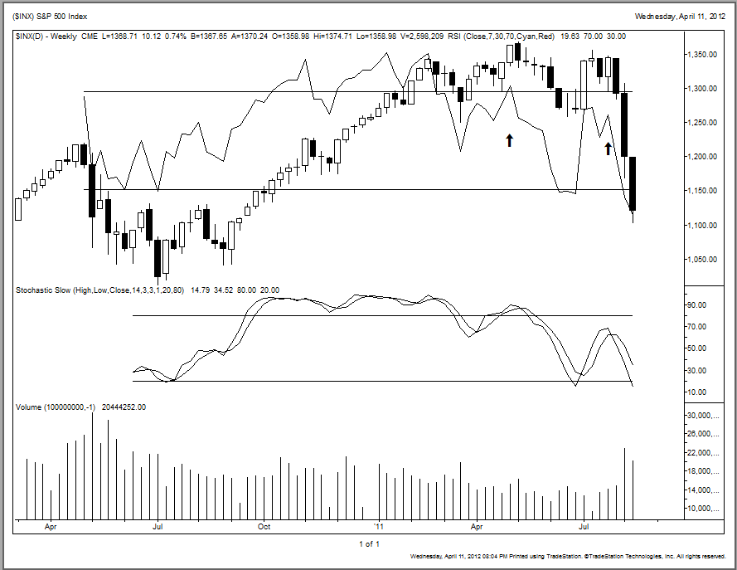
Bearish divergence in the S&P 500

The RSI on April 29, 2010 had decidedly turned lower before the S&P 500 actually broke its uptrend. This was a major bearish divergence and is very apparent in the chart above. The RSI was heading clearly down for several bars before the market finally capitulated. That gave us an early warning that there was an imminent change in the direction of the market. While divergence provides an early warning of a change in direction, it does not illustrate the magnitude of that move. There may be something to the old adage ‘the bigger they are the harder they fall.’ In other words, the longer it takes for the divergence to be confirmed by price action, the larger the potential move.

So why does technical analysis work? Maybe you don't even believe it does. One thing you should understand is that every major Wall Street firm employs technicians. Even if you don't believe that it works or that charts hold any predictive value, lots of other people with lots of money do. I think everyone would agree that is good to know what the big money is doing.

Now I have some theories why this works. I believe human behavior follow certain predictable patterns much like memory metal. If you're driving along the highway and speed limit signs are posted, you know that most people will observe and obey these signs. Charts may not be quite as explicit as a speed limit sign but to the trained eye they are very visible limits. The charts are nothing more then a visual representation of human behavior. Much like an x-ray provides some insight into the body, invisible to your naked eye, the charts will provide another vantage point. Combined with fundamental analysis, technical analysis can give you insight on when to buy and sell.

Our Approach

Our approach is a working marriage of technical and fundamental analysis. The following is a ten-point checklist I use to quickly come to a conclusion on a stock. I score a stock, each item getting a 1, 0, or -1. A stock that scored 1 on each category would be a perfect 10. Buy it! Some of these items are quite subjective. For example, how would I score Cash Flow? If a company’s cash flow is much lower than the reported earnings, that raises a flag and I would score it a -1. If there were more insiders buying than selling, I would score it a 1. If there were no apparent catalysts in the near future I would score it a 0. On the other hand if there was a pending secondary offering that will put more stock out on the market, I would score it -1. By the way, these steps are in no order of importance.

Chart

Know how to read charts. I believe I can improve the price of buying or selling from an understanding of chart pattern. We previously talked about improving the price at which you buy and sell based on just three technical indicators, support and resistance, stochastics and divergence. There are other technical tips that are quick to learn, easy to apply, and nearly foolproof. They just don’t occur that often. Look at unusual volume. When I see blowout volume, six times or more the daily average, this will often be a reversal day to the upside or downside if a trend is in place.

The following is a simple exercise that will add discipline to your purchase or sell decisions. Everyday before the market opens, I put a plus sign, minus sign or zero in front of every holding I own. The plus sign signifies that I think the security goes up today, the minus is down, and the zero means I don’t have a clue. I keep these sheets for several days comparing my predictions to the actual results. The cost of transactions is so miniscule that if I have a high confidence level that a stock is going down, I have to ask myself can I own this stock cheaper tomorrow. If so, why do I want to own it today?
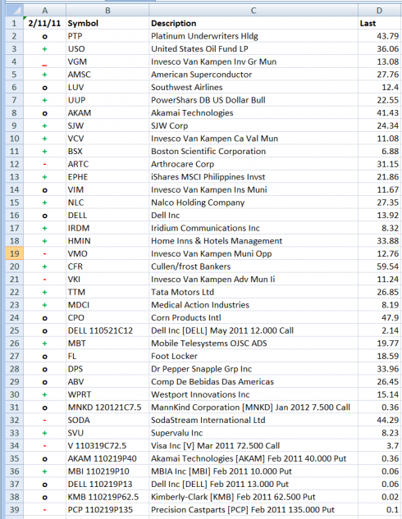

Analysts

Third party research is a lot easier to come by today than it was 15 years ago. Easily available sources like Standard and Poor’s and Morningstar can often be found at your discount broker or the public library. Many discount brokerages such as Fidelity or Schwab offer free access to these reports. There are also traditional wirehouse brokerage research reports, but they are harder to come by. If you find this research valuable to you then open a small account to gain access.

Read analyst’s reports but ignore their recommendations. Research analysts are generally extremely smart people and, although they may know a lot about a company, they are often ignorant of its investment prospects. There is a certain level of ego and peer pressure involved being an analyst. Some are reluctant to get off the bandwagon and slow to admit a mistake. They often issue sells and buys just after a major move down or up at prices you could never have actually gotten. For example, a company announces after hours an earnings shortfall. The analyst downgrades it to a ‘sell’ that evening and uses the closing price as his own sell price. It opens the next day down 20% but you could never have actually gotten out at they analyst’s recommended ‘sell’ price as the market was closed when he initiated the recommendation. There is sometimes a hidden agenda that may involve securing investment banking business, ridding a firm or good customer of it’s inventory, or even just stirring the pot to generate commissions.

“In a bear market, nobody wants to hear from an analyst. In a bull market nobody needs one”

Consider for a moment if you went to a doctor and he told you that you have cancer. “We have to operate immediately on you.” Then after opening you up, he says the good news is you don’t have cancer, the bad news is the operation was unnecessary. A doctor that did this say for every four out of ten patients would have his license revoked after being sued into oblivion. A mutual fund manager with a 60% winning track record could find his photo on the cover of Time.

“Six out of ten is all it takes to produce an enviable record on Wall Street.” Peter Lynch

Insiders

If the people that know the company the best are not buying it, why should you? How many times have you heard that the only good informationbolli is inside information? Everyone takes this for granted. What many people don't realize, is that inside information is available free of charge to the public.
When a C level officer, director or 10% owner trades the stock of their own company, they must file a report with the SEC within 48 hours of the transaction. This information is posted for free on the SEC’s website. If you go to www.sec.gov and look up a database known as Edgar, you can search through this information. Yahoo Finance and MSN Money are popular sites that aggregate this content. Various services will screen scrape that information and repackage it in a more discernable format for a reasonable fee.
Analysts may be extremely intelligent and very knowledgeable about the industry in which they cover. However, they will not be privy to the inside information that the corporate officers and directors possess. I always feel uncomfortable investing in companies in which insiders are not willing to invest themselves. Perhaps it’s because of the time I spent as a CEO of a publically traded company that I developed this viewpoint.
There are many great companies where insiders rarely or never buy their stock. I don’t recall seeing any insiders buying Microsoft stock, yet it was a good investment for quite a while. So is this a missed opportunity due to this strategy? Yes and no. Sure, may miss many great investment opportunities, but I have to believe that I’m missing even more investment disasters by adhering to this discipline.
Insiders sell for many reasons: diversification, new homes, daughters’ marriages, college educations, and legal reasons to name a few. Therefore, insider selling is nowhere near as predictive as insider buying. In fact, with the exception of identifying something known as cluster selling, it may not be useful at all. Some insiders though have a very good track record of timing their stock. After all, if most of your net worth was tied up in something that was quoted every day, you probably would spend some time watching it yourself and would develop a good sense of when it was likely to go up or down.

Insiders buy for just one reason; they think they will make money on it. Now, when I say buy, I'm talking about significant purchases. Purchases of $100,000 or more generally fit this category.
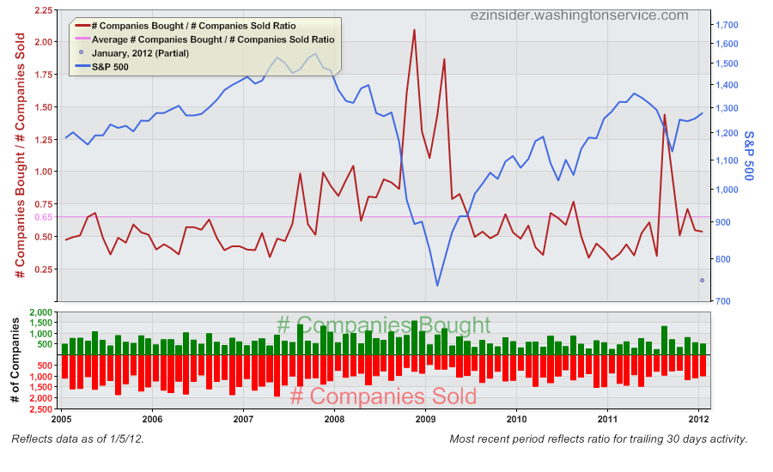

Insiders tend to be value buyers. Nowhere is this more evident than in the chart above. The red line is the ratio of insider buying divided by insider selling. The blue line is the S&P 500 index. The pink horizontal line across the chart represents the normal average of buying and selling. During the market collapse in the fall of 2008, the pace of insider buying reached levels not seen in years. They stepped up their activity again in March of 2009. As it turns out, this may have been the best buying opportunity seen in years. Insiders again stepped up their buying in the summer of 2011 after the market sold off in response to the U.S. budget fiasco and credit downgrade. Once again, they were handsomely rewarded.

So can you beat the market following insider buys?

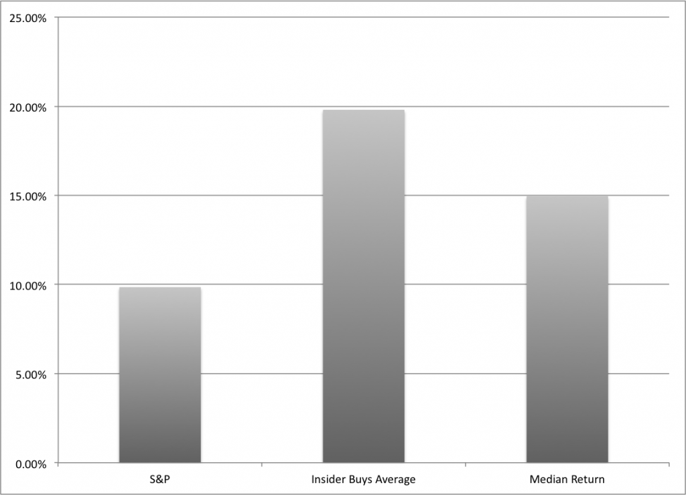
Note: The difference between the average of all insider buys vs. the median return. This suggests that well over half of the insiders performed better than the median of 14.95%.

Our research shows unequivocally you can. Over the last 12 months ending in March of 2012, we tracked 421 insiders that bought $100,000 or more of their company’s stock. Omitted from the list are 10% owners as the value of money may have a different meaning to them a salaried employee. We view them akin to hedge funds rather than true insiders. We don’t look at buys less than $100,000 because that can be window dressing, simply executives trying to pump up investor confidence.
As you can see, the average return on these insider buys was 19.80%, the median return was 14.95%, and the worst was -61.77%. This is a volatile strategy though as the standard deviation was 37.72%. During the same time period the S&P 500 Total Return was 9.85%. Following insiders indeed can be a gratifying strategy.

Management Discussion 10Q And 10K

This is the only truthful thing you will read about a company. Management, the auditors, and the firm’s lawyers compose these documents. If all three of them can agree on the verbiage and content, it’s passed a monumental hurdle. So read it carefully. Pay particular attention to the Risks, Litigation, and Related Transaction sections. These are the things you will wish you had taken the time to read when you find yourself wondering what happened to your investment.
If it isn't true it's probably not going to make it through these three scrubbers. If you don't read the research reports, don't listen to the companies earnings reports, don't read the press releases, and pay no attention to the company’s presentations, all you really need to do is read the 10K, otherwise known as the annual report. Every other piece of information released by the company is essentially propaganda in comparison.
People will listen in on an earnings conference call when the first thing the company does is read their Fair Harbor disclaimer which states everything said after the fact can be completely false and there is no recourse against this. Instead the company will refer you to the 10K in reference to all the risks and potential problems in the near future. My recommendation to you is to read the 10K if nothing else.

Market Direction

80% of stocks follow market direction in the short term. Ever hear the term “don’t try and fight the tape?” Well, Don’t try and fight the tape! The market will always be bigger, stronger, and more right than you. The shorter your time horizon, the more susceptible your position is to market direction. Benjamin Grahm wrote, “The stock market behaves like a voting machine, but in the long term it acts like a weighing machine.” If you’re anything like me, you don’t like loosing money regardless of the timeframe. Pay attention to where the general market is headed. The tools that we illustrated in the technical analysis section will help determine general market direction.

Sector Outlook

Buying a good stock in a bad sector can be a humbling experience. Since 80% of stock direction it is based on the movement of the general market, a strong company in an underperforming sector will likely disappoint. Think of buying a beautiful home in a bad neighborhood. A good tool to quickly identify sector performance and the individual stock components is SmartMoney’s Map of the Market.

Cash Flow

Cash flow is more accurate than earnings. Earnings can be more easily manipulated. Earnings can be misleading and often the quality of the earnings is not clearly understood. For example an abnormally low tax rate, the issuance of stock options, and the improper amortization of research and development are just a few things that can distort the earnings. In spite of these obvious issues, everyone still talks about earnings. Companies pay their bills and their employees with cash. We like to look at the cash flow statement for this exact reason. You don’t need to be a forensic accountant who rips apart the income statement and identifies the correlation between the cash flow and the earnings. What you do want to see is that cash flow in general follows a similar path as the earnings. What I mean by this is as the company grows over time the money needs to show somewhere, either through capital reinvestment in plant or equipment, dividend payouts, or through share buybacks. If it's not, then there's something seriously unhealthy with how the money is being accounted for.

76PEG Ratio

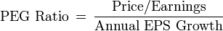

It’s good to find a company growing faster than it’s price earnings multiple. The price earnings multiple (P/E ratio) is the ratio of the stock price divided by the earnings per share. The PEG ratio is the P/E multiple divided by the growth rate of the company. A good way to visualize the P/E ratio is if a company was not growing and it traded at a P/E of twenty, it would take this company 20 years of earnings to pay for one share. Many investors prefer the PEG ratio due to how it explicitly puts a value on the expected growth in a company’s earnings. This process can help identify if a company’s high P/E ratio is a result of an overly high stock price or just a representation of promising economic growth aspects.
It’s preferable to own a company whose PEG ratio is less than one. That means you are not paying a premium for growth. Both the P/E and the PEG ratios have fundamental problems although. That’s why many value investors think that cash flow is a better measure of a company’s worth.
As Peter Lynch has said, “The P/E of any company that’s fairly priced will equal its growth rate.” Keep in mind, this ratio is a rule of thumb and can be misleading when taken out of proper context.

Valuation

Contrary to certain momentum-based investment styles, it does matter what you pay for a company. But how do you know just what the company is worth? This might be the single most important factor in investing. I know Warren Buffet knows exactly what a company is worth in his mind before he commits capital to any opportunity. Buffett uses a discounted cash flow model to accurately assess the value.
We’re not going to go into the intricacies of the DCF model, just look in any intro to business textbook for a thorough explanation. One thing I know Buffett emphasizes in the model is the underestimation of capital needed to reinvest in the business. After all companies just can't depend on a steady stream of revenues without reinvesting in future growth. Factories wear out and innovative ideas grow stale. Besides that, it’s pretty much a plain vanilla cash flow model that he uses.
A handy place to find an online calculator to perform this valuation is a website called www.ValuePro.net. Just plug in a stock symbol, hit submit, and ValuePro will spit out the DCF value based upon a number of different factors pulled from SEC Edgar and other free sources. The service uses quarterly and annual income statement, balance sheet, and cash flow statements to calculate NOPMs and other ratios. The calculations are based on observed historical data. It also attempts to look up data regarding analyst estimates about growth rates. It combines these inputs using the discounted cash flow valuation method described in Streetsmart Guide to Valuing a Stock to come up with a baseline intrinsic value for a stock. If your assumptions differ from current market conditions, you can easily change many of the inputs to reflect your assumed environment.
Both the P.E model and the cash flow model rely heavily on assumptions about future growth. How reliable is your crystal ball? It’s hard enough making forecasts for the next year, how on earth can your predict the business prospects 10 years out with enough accuracy to even put a number on it. Few companies have that kind of consistency and when they do, they are rarely considered value stocks. For many of these reasons, value investors want to know what a company can broken up for and sold, liquidated, etc.

The book value represents the company's common stock equity as it appears on a balance sheet, equal to total assets minus liabilities. Often times though a company has goodwill characterized as an asset and it may or may not have the stated value, or in some cases any value at all. That’s why some investors believe net tangible assets are a better measure of a company’s liquidation value. There can also be off balance sheet liabilities and commitments that can overstate book value. For example Electronic Arts, the largest video game software developer has a pristine balance sheet with lots of cash and no debt. But further reading into the 10k reveals that the company has made billions of dollars of commitments to third party game developers for future products with no guarantee of any success.

Catalyst

What’s going to change the status quo? You've done your research. You figured out what the company is worth, you analyzed the charts, and you think you found an undervalued investment. Certainly it's not going to go up or down just because you see something mispriced in the equation. It needs a catalyst. There are a lot of things that can be a catalyst. For example, a company might not be widely followed and then suddenly a new analyst places a buy recommendation on it and the stock jumps in price. The reverse is true, as an analyst with clout (known as the “axe”) can downgrade the stock and severely impact price, at least over the short term. Often times a business may be sound but a change in opinion about the sector’s prospects can impact its value.

The Ten Point Checklist

Every time I look at a stock, every time, I use this checklist to ensure that I’ve performed my due diligence. Some of these items are quite subjective. For example how would I score Cash Flow? If a company’s cash flow is much lower than it’s reported earnings, that raises a flag and I would score it a -1. If there are more insiders buying than selling, I would score it a 1. If there are no apparent catalysts in the near future I would score it a 0, but on the other hand if there is a pending secondary that will put more stock out on the market, I would score it -1. After running through the checklist, if I have a score of five or more I continue looking at the stock as a potential buy and keep it on my radar.

- CHARTS- know how to read charts. I firmly believe I can improve the price of buying or selling from an understanding of chart action. A good chart gets a 1, a bad one, -1 and inconclusive is 0
- ANALYSTS- read analyst reports but come to your own conclusions. If the consensus is favorable, 1; if unfavorable -1, and mixed 0.
- INSIDERS- if the people that know the company the best are not buying it, why should you?
- MANAGEMENT DISCUSSION 10Q AND 10K- this is the only truthful thing you will read about a company. It’s composed by management, the auditors, and the firm's lawyers. If all three of them can agree on the verbiage, it's passed a big hurdle. Read it carefully. Pay particular attention to the Risks, Litigation, and Related Transaction sections. These are the things you will wish you had taken the time to read if something goes bad with your investment.
- RELATIVE PERFORMANCE- If the stock has a superior relative performance to the rest of the market in the short term, that's a 1.
- SECTOR OUTLOOK- buying a good stock in a bad sector can be a humbling experience
- CASH FLOW- cash flow is more accurate than earnings. Earnings can be more easily manipulated.
- PEG RATIO- it’s good to find a company growing faster than it’s multiple.
- VALUATION- contrary to popular opinion, valuation does matter. Use a discounted cash flow analysis. If the stock is trading for substantially less than its DCF, that's a 1
- CATALYST- what’s going to change the status quo?

A Six Figure Income without Buying a Stock?

One of our favorite strategies is naked put selling. We only do this with securities we would be willing to own. When we can’t find anything to buy at prices we like (for example the market has risen to new heights), we may sell puts on stocks we would be willing to buy if they fell back to a level we were comfortable with. If we get put the stock, we are no worse off than had we bought it at that price. If we don’t’ get put the stock, we captured a nice premium and go our merry way. Never do this strategy as a way to solely create income. You will inevitably get put a stock you don’t want to own and the money you made on the option sold can be dwarfed by the amount you lost getting out of the position.

Based on a CME study of expiring and exercised options covering a period of three years (1997, 1998 and 1999), an average of 76.5% of all options held to expiration at the Chicago Mercantile Exchange expired worthless (out of the money). This average remained consistent for the three-year period: 76.3%, 75.8% and 77.5% respectively, as shown in Figure 1. From this general level, therefore, we can conclude that for every option exercised in the money at expiration, there were three options contracts that expired out of the money and thus worthless, meaning option sellers had better odds than option buyers for positions held until expiration.

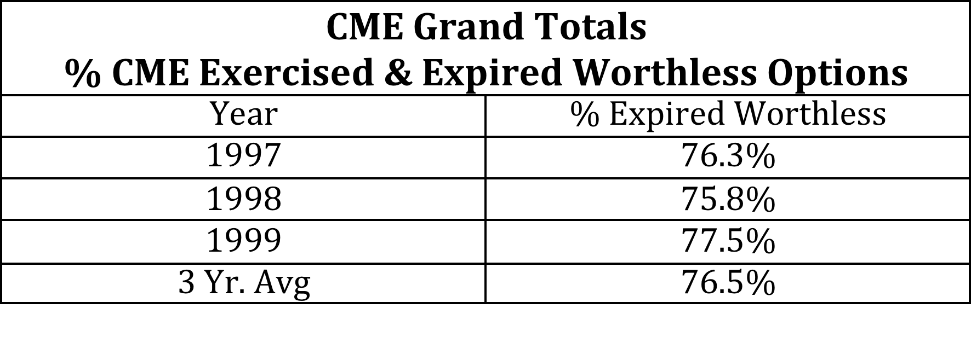

That means that over 76% of all people that buy options are losing all if not most of their money. Unlike equity investing, options have a finite time horizon. It’s
a zero-sum game. If somebody is losing money that means somebody is making money. That means if 75% of buyers of options generally lose money and that must mean that 75% of sellers of options are the ones making the money. The conclusions are simple. I’d rather be a seller of options.

We are going to illustrate this strategy in this chart of Procter & Gamble, a blue-chip stock. At the time, P&G has been trading in a fairly defined range between 60 and 65. The company also pays a healthy dividend of about 3.3% per annum. Now 3% isn’t bad considering you get next to nothing at the bank, but few people would read this book if they expected to learn how to get a 3% return on their money. I certainly wouldn’t. The strategy I am going to demonstrate will earn you closer to 15 to 20% per year.

Look at the price action on Procter & Gamble over the last 6 months. You can see that the stock has been trading in a range between $60 and $65 for the most part. Let's say that you've done your fundamental research on Procter & Gamble and you decide that this is the kind of company you would be willing to invest in. However, you'd rather not buy P&G at the upper end of its price range ($65). Instead you would prefer to buy it at $60 or below.

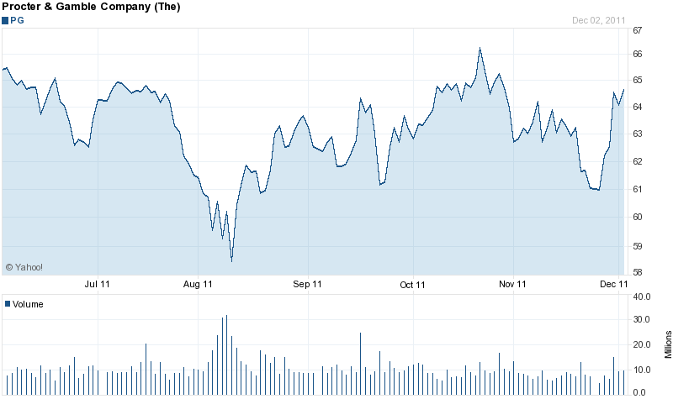
Sell April 65 covered calls at $2.2 and sell April 60 puts for $1.45. Collect $.52 dividend along the way.

In order to create a position in Procter & Gamble below $60 you would sell the April 60 puts. In the illustration above you collect the $1.45 premium for each hundred shares you sold, or $1450 for 1000 shares of Proctor and Gamble. That’s it. You don’t have to own P&G to sell someone the right to put you the stock at $60 sometime before the 3rd Friday of April. The brokerage firm that is handling the transaction will put $1450 into your account less commissions.

Now why would someone would pay you $1450 for the right to sell you Proctor & Gamble stock at $60 when its trading at $63? For starters, they may fear it could go lower than $60 in a weak market. Or this person may simply be a speculator who thinks they know something about the stock that you don't. In either case, you’ll never know the reasons why, just take the money and run.

So if this is so brilliant, why isn’t everyone doing it? First of all, a lot of market pros are doing precisely this. It also takes a lot of money in your account execute this strategy. Although selling puts on P&G puts $1450 into your account, your brokerage firm is going to want to see that you have sufficient funds in you account to pay for this transaction if you get put the stock. One thousand shares of P&G at $60 is $60,000. A far cry from the $1450 put into your account. It takes money to make money. Take some consolation though, most brokerage firms will allow you to do this on margin and have just 25% of the underlying option contract value less the premiums received. (This number varies from firm to firm).

Now let's say the 3rd Friday comes along and P&G has done what its done for several months: nothing. You keep the premium and do this again for the next option cycle. All standardized equity options use American-style exercise. So it’s entirely possible that if P&G is trading below $60 you may get exercised before the last Friday of the month. You have to have the capital at hand in the brokerage house the entire time this option strategy is in place.

Realistically though, is someone going to put me P&G stock before expiration? Nine out ten times the answer is no, even if P&G is trading below $60. But one out of ten it is going to happen and it’s not worth trying to figure out why. The important thing is to remember that it will happen sometime. If P&G is $60 or higher on this expiration Friday, there is no chance you will be put the stock. So what does that mean? That means you have collected $1450 for doing absolutely nothing but being willing to buy P&G for $60 and waiting for the 3rd Friday of each month to make this decision. This strategy is called writing puts, selling puts, or selling puts naked. They’re all the same. And contrary to what some advisors may say, this is one of the most conservative, safest equity strategies. THIS IS ONLY IF YOU ARE TRULY WILLING TO BUY THE STOCK. After all, if you get put the stock, it also was trading in a range you thought was a fair value, so you’re no worse off had you purchased it outright.

Okay, sounds good. What about buying P&G at $60 at your option price when the stock is now trading for $45? What? How could that happen? Easily. Say the market crashes the week your options expire, or P&G has a product recall that killed hundreds of people, or maybe a European bond auction fails. The point is you can’t predict these events anyway, so at least you bought at a price that was at a discount at the time you sold the put.

The prior example is a great way to create a synthetic long position. Now look at what happens when you buy the stock at the bottom of the range and sell a call toward the top of that range. When you sell the call, you give someone the right to buy P&G from you instead of selling it to you. It’s called a covered call. You believe, based on the past six months price behavior, that Procter & Gamble stalls out around $65. This stock appears to be going nowhere at this point, but the company continues to pay a nice dividend. This is a good time to sell a covered call.
Now in this case I'm able to get $2.20 per call for one April 65 option. Just like a put options we sold in the previous example, each call option represents 100 shares of a stock. So if I sold 10 calls that would put $2200, less commissions, into my brokerage account. Now I've given that the buyer of that call the right to buy my Procter & Gamble, so I better have Procter & Gamble in my account to cover my obligation. What’s the worst case that could happen to me here? I sold P&G at $65 at the top of the trading range. I also collected $2200 in option premium. Or I lost a runaway stock that will go much higher. Or I capped my gains at $67.20 ($65+$2.20). Or P&G did not reach $65 and is in fact lower and I now have the stock I owned plus the $2200 premium.

Note: You can do this write strategy every month. I personally prefer doing it every month, as I don’t like to make long-term commitments required by longer term options. How do I know what the world looks like six months out? Besides I like banking coin every month. Don’t you?
Now there’s one thing that I'm very adamant about: I do not use this option strategy of covered calls and put writes to generate income. It's a far different strategy if you really don't want to own Procter & Gamble. After all you cannot get compensated enough by selling puts and calls to cover the substantial price decline of a stock you are not willing to own.

Rules For The Road

When I started investing full-time as a professional in 2001, I already knew a lot about the stock market. After all, I had been a broker for 8 years with some of the top firms. I had even worked at a boutique firm where I was an investment banker and help raise capital for a number of biotech companies. I founded one of the first internet companies and brought it public. In the process I worked with large audit firms and expensive law firms. I sat in a lot of different seats. You could say that I had a 360 degree view of the whole investment process. While this certainly helped, I was still missing some rules and some mentoring from other, more seasoned investors. I knew how to invest and I already had developed a framework for the style that I now have been using the past 10 years but I still felt something wanting.

I knew that successful investment legends like Peter Lynch, Warren Buffett, Julian Robertson, John Henry, Leon Cooperman, Ken Griffin, Bruce Kovner, Paul Singer, Brian Stark, Daniel Och, etc. had many different styles and strategies but what, if anything, did they all have in common? I picked up all the books I could on these investment legends and I sat down very methodically with a yellow marker and paperclips. I went from book to book highlighting the things they had in common. After all, many investors will have different formulas for success as there are many different way of getting to the same spot. I wanted to find out not so much their differences but rather their similarities. I figured that if these ultra successful investors and traders had some investment rules in common, they must be worth a hard and serious look.

Guess what? Even though many of these legends have completely different investment styles, they all had a lot more in common than I ever imagined possible. I summarized these recurring rules in a handy reminder format. I then added my own observations to it. After all, my track record beats most of these legends during the last ten years. I’ve just never had the capital to compete in their arena. I call these observations of market wisdom the Rules For The Road. I post them on my desk so every day I’m forced to stare at them lest not I forget. Bad habits come easy without structure. I suggest you study these rules and post your own version of them in front of your work station.

Be patient and wait for the opportunity.

One of the hardest lessons a trader learns is to do nothing at all. Being able to sit and watch the screen while resisting the temptation of firing off a trade is too much for some people. The Internet, the amazing drop in commissions, and the pulsating and riveting graphics of online trading programs have made it almost impossible to resist trading on impulse or inspiration. Is it really that unlike a casino with iridescent computer monitors replacing spinning, flashing slot machines? Many people learn this lesson the hard way. It’s only when their account values drops to painfully low levels that they wise up. Then again some lose it all before this happens.

All successful traders and market wizards cite the ability to be patient as one of the key ingredients of their success. Just take Warren Buffett, who is fond of comparing investing to the game of baseball. He likes to say you don't have just 3 strikes to get on base. You can wait for that fat pitch you know you can hit. He also likes to say that you should treat investing like a punch card. For example, say you only have 10 punches or investment decisions. It’s rare that 3rd, 4th or 5th best idea is going to be as good as your 1st and 2nd best idea. So be patient and wait for the opportunity. Unless there is a looming catalyst in a particular equity, a dividend forthcoming, a news headline, or a general bull market, it doesn’t hurt the average investor to stay on the sidelines when they are worried or uncertain about a position.

Waiting for the opportunity doesn’t apply to just buying. It’s even harder for many people to determine a proper selling point. I know it is for me. My most reoccurring self-criticism usually revolves around my decision to sell, not to buy. I read where one incredibly successful commodities trader put a position on that was working splendidly for him. Making profit hand over fist, he continued to leverage the trade into gigantic gains. Unable to resist taking profits, the trader left the country and traveled somewhere where he knew he would not be able to get quotes or news on the trade, much less exit it. Sometimes waiting is the hardest thing to do. And sometimes doing nothing is the smartest thing to do.

When I feel my compulsive desire to trade coming on, I’ll drop everything and hastily drive to the ski slope to get a few market distracting turns in. Now that ski season is coming to a close, I’m really worried about what I’ll do to compensate for my trading proclivity.
Don’t mistake patience though for paralysis. I would much rather would have a case of itchy fingers than a lack of conviction.

Trade on your own ideas.

I talked about the various styles of investing. There are many different ones, but not every style is suitable for everyone. You ultimately have to trade and develop your own ideas. Successful investing requires conviction. Even the best ideas rarely work immediately. You will have your conviction tested and if you are not a believer, you will get shaken out. Fear will overpower logic, and you will take a loss needlessly. And naturally, investing on your own style means avoiding hot tips and rumors. It’s rare that these situations ever work out.

Review and learn from your mistakes.

Another thing many people fail to do on a regular basis is review their returns. You would review your child's report card wouldn’t you? If you don’t learn from your mistakes, how are you ever going to improve? Look at the percentages, not dollars. All too often the big dollar movers steal the headlines. A stock trading at $5 that moves up a dollar has moved 20%. A $500 per share stock that moves up five dollars has only moved 1%. What would you rather have? A 20% gain or a 1% gain?

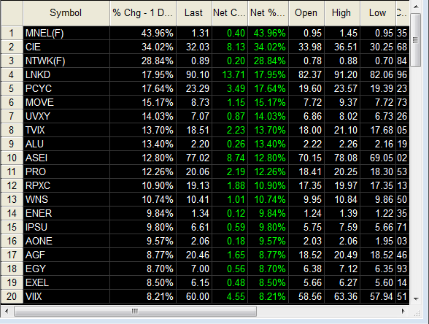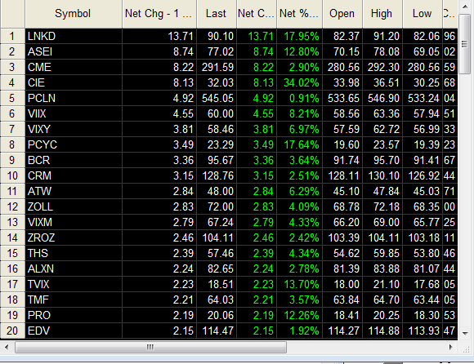

You have to be able to sleep at night.

Being unable to sleep at night is no condition for any investor. Irritability and irrational behavior are all unfortunate consequences of an over-concentration of risk. A lot of people will tell you that diversification is the key to success in the market. I disagree. Diversification is key to tolerating the pain. And tolerating the pain is key to emotional indifference and that is the KEY to winning market behavior.

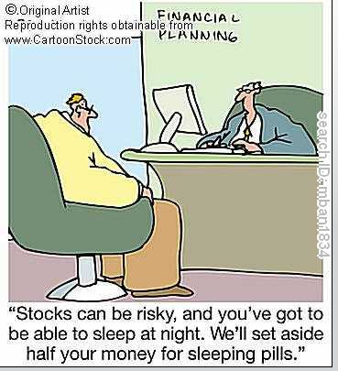
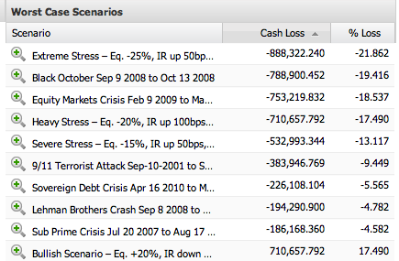

StatPro provides complex risk analysis. This is a screenshot of theoretical portfolio results after major events.

VaR is a technique used to simulate probability of estimated portfolio losses based on the statistical analysis of historical price trends and volatility. If there was another 9-11 event, are you prepared to handle that kind of paper loss? Mental preparation is essential to avoid real world irrational behavior.

Part of that preparation is in knowing the beta of your portfolio. Beta is a measure of the volatility of your investments. The beta of your portfolio is just an equal weighted summation of the beta of the individual stocks within. The beta of the market is 1, so if you own a security that has a beta of 1 it's likely to go up and down in kind with the whole market. If you own a security with a beta of less than one then it's going to be less volatile than the stock market. Cash has a beta of zero since cash is not impacted by moves in the stock market. A negative beta would be something that's inversely correlated with markets. If the market goes up something with a negative beta will go down and visa versa.

A simple and quick way to find out if you are an aggressive or a conservative investor is to find the weighted average of all stock betas in your portfolio. It’s a lot easier to do than it sounds. Use a spreadsheet like Excel and look up the betas of your individual stocks. You can find this information very easily on Yahoo Finance, MSN.com, and other popular financial sites. Define the allocation of each stock in relation to your overall portfolio. For example, if your overall portfolio value is $10,000 and $5000 of that comes from Apple then 50% percent would be the allocation for Apple. The beta for Apple is 1.29 so multiply .50 times 1.29 to find the weighted beta of .645. Do the same thing for all the remaining positions in the portfolio and then add them up. You’ll have your portfolio beta in four easy steps.

STEP 1: Look up the beta of your individual stocks. It’s easily found on Yahoo finance or other popular stock market quotation sites
STEP2: Find the allocation of each stock in relation to your overall portfolio. For example if your overall portfolio value is $10,000 out of which $5,000 comes from Apple stocks, that’s a 50% allocation for AAPL
STEP 3: Multiply the individual stock beta with the allocation percentage. For example the beta for AAPL is 1.38. 1.38 X 50% = 0.69
STEP 4: Add up all the weighted betas to arrive at your portfolio’s beta

It’s certainly easy enough to come up with the beta of your portfolio, but finding your own mental beta takes more than a few quick calculations. There's an emotional part of knowing one’s self that can’t be measured with traditional yardsticks like beta.

Don't risk too much on any one idea.
This is the one rule that everyone agrees on. You will be wrong often. You will make mistakes. Even the best investors in the world do, so holding yourself out to a higher standard is foolish. The best laid plans can and often do go wrong. No matter how much you may like a particular investment, you cannot put everything you own into it. Always leave yourself and out and be prepared to fight another day.

“Even being right three or four times out of 10 should yield a person a fortune if they have the sense to cut losses quickly.” Bernard Baruch

Diversification is crucial but too much diversification will establish nothing more than mirroring market performance. So what is the optimum allocation? Most successful traders and investors say that you cannot put more than 8-12% on any one idea or 20-25% in one sector or theme.

Beware of yesterday's events.
When I was a broker at PaineWebber I used to train other stockbrokers. Every week we would have mutual fund wholesalers come in to the office, buy us lunch and show us their funds. One day while we were finishing up lunch and the wholesaler was just getting into his dog and pony show, I interrupted him. I said today we want to hear something different. You come here month after month and tell us all about the best performing funds your company has to offer. I want to hear about the worst performing funds. We’ve been selling the best performing funds to our clients, and they seem to turn into the worst performing funds. So let's just start with the worst performing funds. Now I said this with more than a touch of sarcasm, but there is a certain amount of truth to my statement. There is a reversion to the mean in both life and the markets. Just look at last year's biggest winners in stock market and see how they are doing this year.

Volatility breeds opportunity.
Another important thing to remember, particularly these days, is that you are never going to do well when you panic in a volatile situation. Often times the best opportunities present themselves while others flounder in their own personal uncertainty and fear.

“You have to keep your head when others are losing theirs. “ Warren Buffett

Anticipate don’t react.
Develop a future time horizon. It does little good to figure out what's happening today. You need to change your mindset to think about what's likely to happen tomorrow, six months from now, or even what will occur in a year. Most people go to bed thinking about what they are going to do tomorrow. We wake up and think about the day ahead of us. In 2001 when I started investing professionally, I was getting up at 7:00AM EST and reading the papers, research, etc. preparing myself for the market open at 9:30AM EST. So when I moved out to Park City, Utah in 2004, I was really worried about how early I would have to get up since Park City is two hours behind the East coast. I thought the two-hour time difference would be an enormous handicap on my market trading activities. So I started getting up at 4:00AM to compensate for the two-hour time difference. I did this for a few days, or maybe a few weeks before I came to the conclusion that if I was trying to figure out what would happen today, I was already behind the curve. What was going to happen today actually already happened last night in Tokyo or China or that morning in Europe. Or what was happening today was often already determined over night in the futures market. As a result, I try not to think about what is going to happen in the immediate future. I think about was going to happen one week from now. So as an exercise, you could pick a day and write down what you think will happen one week from today or a month from now and see how accurate you might be. It’s not as difficult as you think. There are published economic calendars, conferences, earnings reports, and the daily news flows. Work your mental muscles just like you might work out in a gym three times a week. If you read the headlines, you stay abreast of current events, you will have some idea of what may happen in the world a week from now or even six months out.

Listen to the markets.
You have to be flexible and open-minded. The market is always telling you something. Stand back and listen. Much like the Zen Buddhists believe in the quieting of your mind in order to see clearly, calm your mind and listen to the sounds of the market. Often times you'll see peculiar price movement they may be signaling some news about to break. This strategy often portends the facts on the ground. If news is relentlessly negative yet the price action is driving higher, the market might be telling you that the sellers are exhausted and the price has reached a floor.

Think trades through.
Before you buy any security, let alone sell one, you need to have an exit strategy in mind on both the upside and downside. For instance, what’s an acceptable profit and just how much loss can you endure? And if you're unsure of your position in the slightest, just get out. More on that next, but this was one of the most surprising facts I discovered when comparing all these famous investors with each other. You would think every investor is smart enough to do exhaustive research before they invest. This is simply not the case. Many traders will buy and sell the same security multiple times in the same day before making up their mind about what they really want to do.

If you are unsure just get out.
If you're unsure of yourself, especially if you think you’ve made a mistake, just get out. Commissions and transaction costs have plummeted in the last 15 years. The rationale behind staying put and minimizing transaction costs is not nearly as compelling as it used to be. Think of the commission as a price to change your mind. This is cheap in comparison to having a stock move a few points and then you decided that you made a mistake. Take a $10 or $15 commission loss now versus taking a thousand dollar loss later when you conclude the trade was wrong. Once you have more conviction on the certainty of the outcome, you can often get back in around the same price.

Another alternative is to reduce the size of your trades when you’re on a loosing streak. Trading or investing is a lot about behavioral psychology. Maintaining your confidence is the single most important thing an investor can do. It’s also the hardest.

So when is maintaining your confidence, just a psychological ruse? It’s easy to keep yourself in denial about a losing position. You say to yourself the merits of the investment are the same and if you just wait, it will come around. You believe the market is mistaken. You quit looking at the painful situation and let it deteriorate further. Finally in an act of desperation, you close out of the position and swear you will never touch that security again. Sound familiar?

This is all very typical behavior. One way of combatting indecision and denial is to just get out. There is nothing wrong with buying and selling the same security multiple times until you develop the conviction needed to stay in the trade.

Force yourself to trade against the consensus.
The consensus opinion is rarely the most profitable pursuit. It's just common sense. If 28 out of 30 analysts have a buy on the stock, you have to ask yourself “who left to buy the security?” Often times the least followed stocks are the biggest movers as analysts jump on the bandwagon of a good story.

Start each day anew.

I print out all my positions every day and play a little game. Next to each stock symbol I write a +, -,or 0 depending on whether I think the stock is going up today, down today, or I have no idea. I want to be able to say to myself that I would buy the stock today regardless of the fact that I already own it; essentially that it would be an acceptable addition to my portfolio today at its current price. If it’s nota good buy, then I rethink why I own this security. Or if it is, I wonder if I should be buying more of it. It's a good habit to start each day with a fresh slate in mind.

Recognize winners and losers fast.
I don't believe in cutting losses, but I believe in recognizing mistakes. That’s not necessarily conventional wisdom. When I was a stockbroker at Bear Stearns, Ace Greenberg the legendary CEO would tell his traders that if you had a ten percent loss you get out of the trade, no questions asked. I don't really believe this is a successful rule for trading. It may have worked for Ace but it certainly didn’t work for Warren Buffett or Julian Robertson.

“Don’t cut losses, instead recognize mistakes.” -Julian Robertson

I recall reading a story about Robertson, the legendary owner of the Tiger funds. One of his traders came to him with a problem with one of their positions. The problem was causing a $100 million loss in the portfolio. On Robertson’s request, he promptly related the all the facts and reasons why they were in the position to Julian. Mr. Robertson replied, “Well if you like the story, the thesis is still intact but the position has gone down 50%, you should like it a lot more. We should double up the position.” This is where great traders make their mark in history. That's the difference between cutting your losses and recognizing mistakes. If you're wrong, just get out. It doesn't matter whether it's 5%, or 50%. When you're wrong, no amount of reasoning can negate that mistake. But if the price has simply moved against you, buy more. Always remember the rule about diversification however. It’s easy to dollar cost average yourself into an oversized position.

Press your bet when you are right.

“When you knew you were right, there was no such thing as betting too much.” George Soros

When things start to line up the way you expected, bet more. But it’s easy to become overconfident if you’re not careful. That’s the quickest way to turn a profit into a loss when things start going right for you. Don’t start ignoring the rules and lessons you’ve learned just because you are starting to print money.

Force yourself by on extreme weakness and sell on extreme strength.

We simply attempt to be fearful when others are greedy and to be greedy only when others are fearful. -Warren Buffet

This is perhaps the hardest thing to do for any investor. You have to go against your emotions and logic here. After all, no one wants to sell a stock that is dramatically rising, just as nobody wants to invest in a stock that looks like it’s tanking. When the market is tumbling and I have this sick to my stomach feeling, that’s when I know its time to step up and buy.

You will never make money in the market if you are too afraid of losing it.
Last but certainly not least stay confident, the opportunities never stop. You may be down and out today but before you know it, you will be over it. Forget about the losses and concentrate on how you are going to make money. Every day there is a new list of the 50 biggest winners and the 50 biggest losers. Try to get some positions on the winning list and of course avoid the losing list. Each day is a new day. Try to treat it that way.

As I mentioned before, I always keep my “Rules for the Road” easily visible wherever I’m working or trading. We created a list of our rules for your own use, so feel free to add to them so they fit your trading style.

- Be patient and wait for the opportunity.
- Trade on your own ideas.
- Review and learn from your mistakes.
- You have to be able to sleep at night.
- Don't risk too much on any one idea.
- Beware of yesterday's events.
- Volatility breeds opportunity.
- Anticipate don’t react.
- Listen to the markets.
- Think trades through.
- If you are unsure just get out.
- Force yourself to trade against the consensus.
- Trade pattern recognition.
- Start each day anew.
- Recognize winners and losers fast.
- Press your bet when you are right.
- Force yourself by on extreme weakness and sell on extreme strength.
- You will never make money in the market if you are too afraid of losing it.

Investors Tool Kit

Here you will find a diverse selection of Sax Angle recommended sources for serious investors. While some of these tools are not free, we at the Sax angle have gathered together some trial memberships to help you get started. These are all services that we have found worth the money over years of investing. While not everyone’s budget can accommodate the full quiver of tools, we do recommend that you find some way to cover all these crucial sources of information.

Insider Trading Info
If the people that know the company the best aren’t buying, why should you?
http://www.washingtonservice.com(Requires Account)
Market Intelligence
We have been using Briefing for years and it helps to know why your stock is plummeting or rising mysteriously.
www.briefing.com (Requires Account)
Trading Software
If you want to be the best, use the best.
www.tradestation.com (Requires Account)
Up to-the-minute financial news
We like the new beta audio feature. It’s even faster than the web version.
www.theflyonthewall.com (Requires Account)
What is a company worth?
There’s a difference between a good company and a good stock. Price does matter.
www.valuepro.net
Map of the Market
Informative, interactive infographic of the market
Smart Money Map of the Market
Bloomberg
The gold standard. If you can afford it, why not? Their soft terminal software can do just about anything and has more info than any one human can digest.
www.bloomberg.com

Financial Blogs

I don’t believe reading these blogs for the most part will consistently or even rarely make you money. But sometimes nothing will. And for those times, reading about making money will have to do:
Exchange Traded Funds
Exchange-Traded Funds (ETF) Center
There are over 1500 ETFs now. This is the best place to find information on what’s out there. Many of these ETFs will fail, not attract enough investor interest to stay listed or not perform as advertised. Many of these ETFs are fundamentally flawed. THEY DO NOT DO PERFORM THE WAY YOU THINK THEY SHOULD. That being said everyone buys them and they offer an immediate and convenient way to get in or out.
via ETF Channel

Getting Started: We’re Here To Help
This is a list of the services we know and trust. They have been gracious enough to provide our readers with a free trial of their products.

Source SEC finding: From approximately June through September 1994, David Blech, the chief executive officer of D. Blech & Co., Inc., orchestrated a massive manipulative scheme designed to increase or stabilize the prices of a number of the biotechnology securities for which D. Blech & Co. was a market maker. Silverman, the head trader at D. Blech & Co., and Prodani, a trader at another broker-dealer, participated in this scheme. As part of this scheme, David Blech routinely sold biotechnology stocks from D. Blech & Co.'s inventory accounts to brokerage accounts that Blech controlled that were in the names of other individuals and entities. These controlled accounts then sold the biotechnology stocks back to the brokerage firm or to other accounts controlled by David Blech. These trades created the appearance of active trading in the biotechnology stocks. Additionally, through this trading, Blech was able to reduce D. Blech & Co.'s inventory position in the biotechnology stocks, yet still artificially withhold from the market the supply of the biotechnology stocks.
From Investopedia A means of paying brokerage firms for their services through commission revenue, as opposed to through normal direct payments (hard dollar fees). The investing public tends to have a negative perception of soft dollar arrangements because they believe that buy-side firms should pay expenses out of their profits, rather than from investors' pockets. As such, the use of hard dollar compensation is becoming more common. For example, a mutual fund may offer to pay for research from a brokerage firm by executing trades at the brokerage.
Annualized return (-True CAGR) includes reinvested dividends. See http://www.moneychimp.com/features/market_cagr.html for calculator
The S&P 500 began the year 2001 at 1320.5 and ended 2008 at 903.24
Over five years ending June 2008, S&P 500 outperformed 68.6% of actively managed large cap funds, S&P MidCap 400 outperformed 75.9% of mid cap funds and S&P SmallCap 600 outperformed 77.8% of small cap funds. S&P press release dated November 12, 2008.
See letter from independent accountant in the appendix.
Compound Annual Growth Rate (Annualized Return) A problem with talking about average investment returns is that there is real ambiguity about what people mean by "average". For example, if you had an investment that went up 100% one year and then came down 50% the next, you certainly wouldn't say that you had an average return of 25% = (100% - 50%)/2, because your principal is back where it started: your real annualized gain is zero. In this example, the 25% is the simple average, or "arithmetic mean". The zero percent that you really got is the "geometric mean", also called the "annualized return", or the "CAGR" for Compound Annual Growth Rate. source www.themoneychimp.com
Efficient Market Theory
from www.thismatter.com Copyright © 2005 - 2008 by William C. Spaulding
As published in the Wall Street Journal 5-6-09
The yield on a 30 yr AAA municipal bond published in the Wall Street Journal 5-6-09
Chart from www.Investopedia.com
A point about exercise of options so as not to get confused: the last day to exercise an American-style option is usually the third Friday of the month in which the contract expires (expiration Friday). Most index options, however, use European-style exercise. This means that the only time you can operationally exercise your contract is the last trading day (usually Friday) before expiration. Remember, even though there is only one day in which you can exercise your contract, you can always close out your option position in the secondary market any day prior to expiration.

